USER MANUAL

DUPLEX SOFTENER
CSOFT MV UFS D18-D63

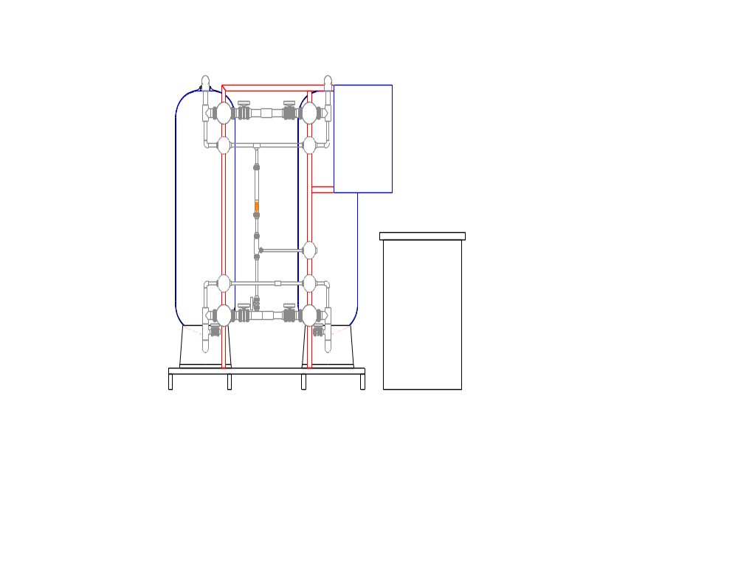

Table of contents
1. Safety instructions 4
1.1. Introduction 4
1.2. Understanding 4
1.3. Qualification and training of employees 4
1.4. Ignoring the safety instructions/hazards 4
1.5. Safe operation 4
1.6. Adjustments to the installation and spare parts 5
1.7. Unauthorised operation 5
1.8. Safety instructions 5
1.9. Maintenance 5
1.10. Monitoring/follow-up 6
1.11. Monitor sheet 7
2. Feature 8
2.1. Objective 8
2.2. Objective 8
2.3. Operation 9
2.4. Cleaning cycle 9
2.4.1. Brining 9
2.4.2. Slow rinse 9
2.4.3. Backwash 9
2.4.4. Filling the brine bin 10
3. Fitting and installation 11
3.1. Check the delivery 11
3.2. Location 11
3.3. Qualification of plumbers 12
3.4. Qualification of electricians 12
3.5. Qualification of the installation employees 12
3.6. Installation 12
4. Filter mass: calibrated sand, resins suitable for supply 19
4.1. Use 19
4.2. Specifications 19
5. Lay-out water softener and valve position 21
6. Technical data duplex softener 22
7. Control box 25
7.1. System 25
7.1.1. Plant cycles 25
7.1.2. Control box 27
7.2. HMI – touch screen 27
7.2.1. Information Hydris 27
7.2.2. Overview 28
7.2.3. Automatic/manual 29
7.2.4. Matrix regeneration 32
7.2.5. Counters 33
7.2.6. Settings 35
7.2.7. Alarms 39
8. Electrical circuit diagram 41
9. Parts list 92
10. EC declaration 94

Safety instructions

Introduction
Please read this manual carefully before installation, start-up, and operating the device. This manual contains general information for the correct assembly, operation and maintenance. This manual should be stored with the device.

Understanding
! HAZARD Indicates that a certain situation may cause personal damage or damage to the system.
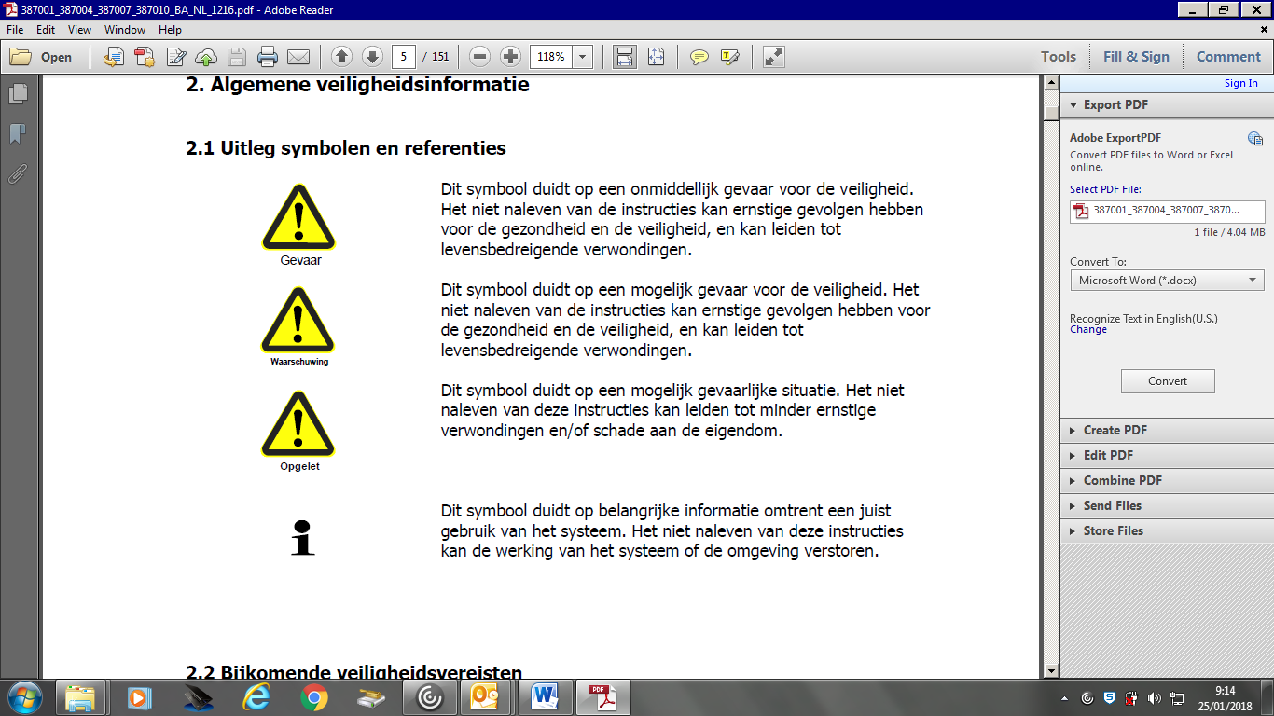

! INFO! Provides information to make the operation of the device simpler and safer.

Qualification and training of employees
Employees working on or with the system must be qualified for this type of work. The employees must be trained and given instructions. The employees must read and understand the entire contents of this manual prior to starting the assembly, the commissioning, start-up or maintenance.

Ignoring the safety instructions/hazards
Non-adherence to the safety regulations may cause damage to the system or persons resulting from electrical or mechanical breakdown.

Safe operation
The instructions in this manual and existing regional and/or national regulations for accident prevention must be adhered to when working on or with the system. Maintenance of the unit is only permitted when the system is switched off.

Adjustments to the installation and spare parts
Alterations or adjustments are only permitted after written agreement with the manufacturer. Only use original parts that have been approved by the manufacturer. The use of other parts shall invalidate the warranty.

Unauthorised operation
The system must only be used for the purpose for which it has been designed, and with respect for the technical features and limitations set out in the “technical information”. It is strictly prohibited to use the device outside of these limitations.

Safety instructions
It is the responsibility of the operator to ensure that any work in connection with the maintenance, inspection and fitting is carried out solely by authorised and qualified employees.

Prior to any repairs or maintenance being carried out, the system must be stopped and secured against ‘inadvertent restarting’.

Before work is carried out on the electrical system and facilities, it has to be checked whether the system is voltage-free. Moreover, the system must be safeguarded against ‘inadvertent restarting’.

During maintenance, employees must wear protective clothing appropriate for the hazards.

Immediately after termination of the maintenance, all safety devices must be refitted and rendered operational.

Maintenance
To guarantee the long-term problem-free operation of the system, regular maintenance must be carried out on the system, and the operating parameters must be recorded, logged (see example page 7) and submitted to the manufacturer regularly.

The operator of the system carries out the maintenance and records the operating parameters.

By entering into a maintenance contract with the supplier, the latter may take over the responsibility for regular maintenance.

A protocol sheet must be maintained for recording the parameters. This protocol sheet can be found on page 7 in this manual. The objective of maintaining this protocol sheet is an ongoing registration of the operating parameters. Breakdowns in the system may be detected and resolved quicker this way. Maintenance must be recorded on the maintenance protocol provided to this end.

The brine pipe, resins and discharge pipe can be cleaned using PA103/5 (item no. 1004020060). This liquid product is poured in the brine bin after which a regeneration is started. This must be repeated a second time for the other vessel!

Monitoring/follow-up
The following parameters must be monitored and recorded daily or weekly:
- Date
- P in
- P out
- TH in
- TH out
- IWT in
- IWT out
- Q out
- Last capacity 1
- Last Start 1
- Last capacity 2
- Last start 2
- EC drain
- Service 1 or 2
- Salt consumption

Monitor sheet
Client: __________________________________________________ System type______________________________________________

Item no.:_______________________________________________ First Start-up:______________________________________

DATE | Pressure INLET | Pressure OUTLET | Hardness INLET | Hardness OUTLET | Water meter INLET | Water meter OUTLET | Flow Rate OUTLET | last capacity 1 | last regen 1 | last capacity 2 | last regen 2 | Conductivity DRAIN | SERVICE 1 or 2 | SALT Consumption

Feature

Objective
Softening or demineralisation is a much used, very robust method to remove calcium and magnesium from water. The filter bed consists of a specific cation resin. By way of ion exchange, calcium and magnesium are removed.

Objective
Softening or demineralisation is mostly considered a chemical process, exchange of ions.
Softening or demineralisation is a widespread method to remove Mg and Ca from water. In most of the cases, the filter bed consists of a layer of resin with a uniform particle size:
- The gravel bed supports the filter material to prevent fine resins from escaping the system. The gravel bed supports the regeneration to properly disperse water and brine.
- The resin is solely responsible for the ion exchange.
- On top of the resin is a layer of inert resin to prevent the upper divider from getting blocked by small resin granules and to prevent fine resins from escaping the system. Moreover, this layer ensures proper dispersion of the brine across all of the surface of the tank.
Most common applications:
Softening for:
  - Cooling water production;
  - Boiler water production;
  - Sanitary water;
  - Pre-treatment potable water production;
  - Pre-treatment membrane technology;
  - Post-treatment water.

Operation
In service the flow of the untreated water runs from the bottom to the top through a resin-filled tank. After having treated a certain amount of water, the resins must be regenerated. This procedure may be activated on the basis of:
- Timer control
- Volumetric water counting
- Hardness reading at outlet
The filtration speed is high, up to 40 to 60m/h to ensure the exchange of Ca and Mg ions through the resins. On the other side, the backwash flow rate will be low (13m/h) in order to rinse the filter bed properly while minimising water consumption.
Untreated water flows through a valve system in the bottom of the tank through the resin bed. Any hardness is exchanged in the resin bed.

Cleaning cycle
The softener must be regenerated on a regular basis to reload the resins with sodium ions. The interval depends of the hardness of the supplied water, the resin volume, the brine volume and the purified water volume.

Brining
After ‘end of capacity’ the microprocessor operates the pneumatic control of the valves. The resins are flooded with NaCl. This requires saturated brine which is absorbed during approx. 30 minutes. Ca and Mg are exchanged by Na. The resins are now reloaded with sodium.

Slow rinse
After brining (all brine has been absorbed from the brine bin) the device runs a slow rinse. The brine is displaced by water. The brine remaining in the tank will be rinsed slowly through the resins. Thus all brine is made 100% useful. Once the brine has been displaced, the rinse of the resin bed starts.

Backwash
After the slow rinse, the microprocessor operates the pneumatic control of the valves again. Treated water flows into the top of the filter tank. The water runs through the resins, remaining brine is washed away. The rinse water exits the filter tank through a supporting layer of the gravel to the bottom distributor and flows on to the drain. An EC meter on the drain ensures that a minimum in water is consumed.

Filling the brine bin
After the backwash, the microprocessor operates the pneumatic control of the valves again. Just enough water flows back into the brine bin to form brine for the following regeneration.
If ready-to-use brine is available on site, the extra relay may be used to turn on the brine pump. Turning on the pump occurs at the end of the regeneration during the time programmed in ‘brine refill’. An extra electric float in the brine bin will stop the pump once the level has been reached to prevent overflowing.

Fitting and installation

Check the delivery
You must unpack the system first.
Before fitting the softener, please make sure that all parts have been supplied and nothing was damaged during transport. Any deviations or damage must be reported to the manufacturer immediately.
Transport the system carefully with a suitable lift vehicle to the appropriate location.
Please take extra care with the lower dividing systems before filling the tank. Please contact us immediately in the event of broken or missing parts.

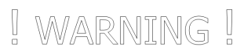
Location
The system must be installed in a clean and dry space, protected against frost or extreme heat with sufficient ventilation.
The required positioning space can be derived from the technical specifications (see technical information 6.0). In addition, a space of 1 metre around the system is required for the operation and maintenance of the system.
The floor must be even, level and sufficient load bearing to be able to support the system in operation (see technical information 6.0).
The softener must be placed in the vicinity of a properly working drain. The capacity of the drain must be checked in relation to the flow rate of the backwash flows (see technical information 6.0).
To prevent flooding due to leaks the positioning space must be fitted with a drain in the floor and/or leak protection fitted with an alarm.
The drain pipes must be shorter than 5 metres. The drain cannot be higher than 1 metre above the drain of the softener.
At the location, the required electrical connections must be available within a distance not exceeding 2 metres from the system.
The supply water connection must be provided with a valve.
The supply water pressure must be between 3 and 6 bars, please provide a suitable pressure pump or pressure regulator where appropriate.
A compressed air connection with expansion valve must be provided within a maximum distance of 2 metres. The connection to the control box to be fitted is tubing 6mm.

Qualification of plumbers
The waterside connection may only be fitted by qualified professionals. When installing the system, the general guidelines and local installation regulations must be observed.

Qualification of electricians
The electric connections must only be fitted by electricians in conformity with the applicable national and regional regulations.
The wiring diagram of the system is provided in the appendix to this user manual.
Check if the relevant main switch is turned off prior to connecting the supply voltage. Connect the supply voltage for the system and check and fuse it according to the specifications (see appendix in this user manual; the electric circuit diagram).

Qualification of the installation employees
The commissioning of the system must be carried out by qualified employees.
Prior to commissioning of the system, all screw connections must be checked.

Installation
Put the tank safely in a straight position according to the local safety regulations. Compensate the level difference with appropriate corrosion-proof material where necessary. See specifications on the tank for securing and placing it in a straight position.
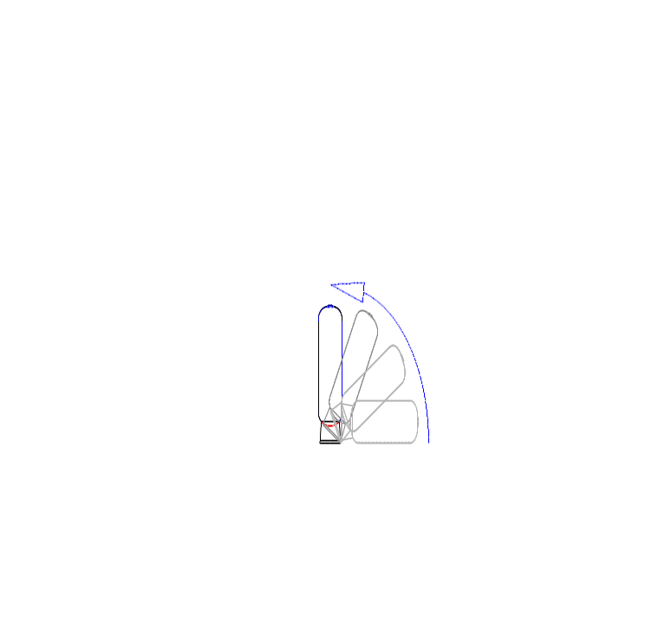
Do the same with the second and third filter if it concerns a duplex or triplex.
Check the lower lateral distribution systems. Should the distribution systems be damaged, please contact your supplier immediately.
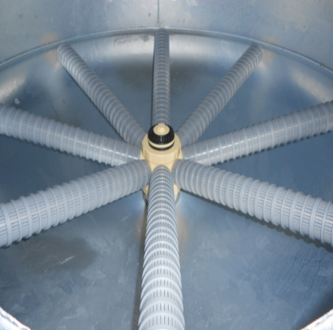

Straighten the stainless-steel supports supporting the PVC collectors (manifold). Fit all PVC parts as shown below. Ensure that everything is level to prevent the PVC from pinching. Should you encounter problems or difficulties in this respect, please contact your supplier.
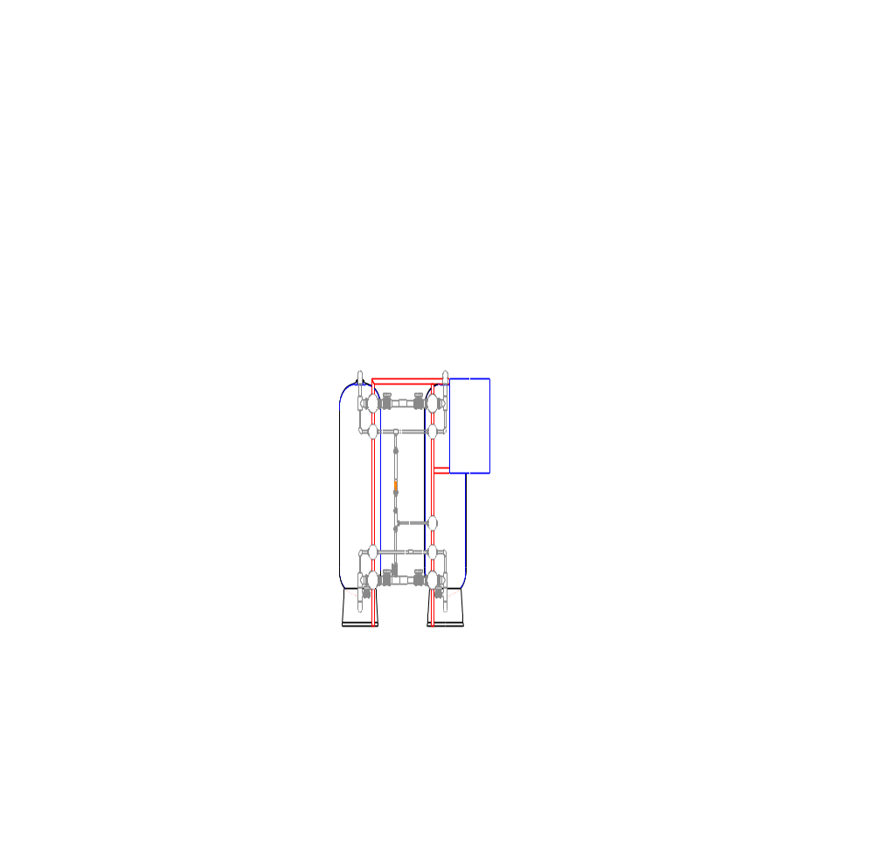

Disassemble the top distributor and upper pipes so that the tank can be filled with water, Silex and resin.
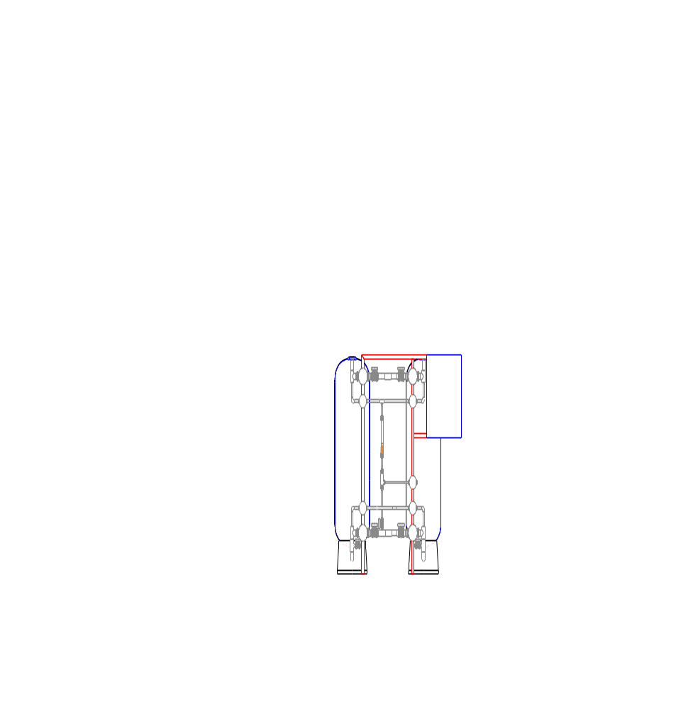

Fill approximately 1/3 of the tank with water via the top opening with a flexible pipe. This will break the fall of the Silex (during filling) and protect the bottom distributor.

Fill the gravel layer in the tank first. Distribute the supplied Silex across the vessels.


Fill the tank subsequently with the supplied resin via the top opening. Distribute the supplied resins across the vessels as well.
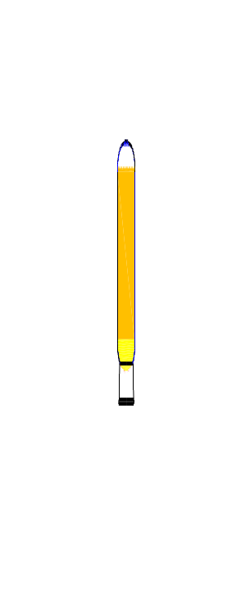

Fill up the tank with the supplied inert resin via the top opening and fit the top distributor and the PVC pipe work.

Use the correct pipes (in diameter and material) to connect the system according to the local regulations and plumbing codes.
Pipe connections must be voltage free. Pipes must be adequately supported to prevent stress. The pipework must be able to deal with any tank expansion. Where necessary, use flexible connectors. Use flexible connectors according to the recommendations of the tank manufacturer. Take the necessary measures against possible water hammer.
Discharge pipes must be placed slanted up to the drain. Limit the use of bends and T's. Ensure a free discharge flow of waste water.
Vacuum breakers must be installed to prevent implosion of the vessel. See technical recommendations of the tank manufacturer. In case of a risk of a vacuum (absolute pressure < 0.1 bar) if the system was installed before a booster set or an RO system, a vacuum breaker must be installed. Vacuum may cause damage, the softener may implode!
The client/installer must place the required non-return valves and safety valves both in the inlet and outlet pipes.
A manual bypass across the softener facilitates maintenance.

Filter mass: calibrated sand, food grade resin

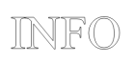
Use
Most common applications as a softener for:
- Cooling water production;
- Pretreatment potable water production;
- Pretreatment membrane technology;
- Post-treatment of waste water

Specifications
Resin is a copolymer of styrene and divinylbenzene in the shape of sodium. This product is not classified as hazardous according to EC criteria. It is a top product that complies with all specific safety, health and environmental regulations and legislation for the substance or the mixture.

“US Toxic Substances Control Act" (TSCA)
All components of this product have been included in the TSCA list or have been exempted under no. 40 - CFR 720.30.

“European inventory of existing chemical trade substances” (EINECS)
All components of this product have been included in the EINECS list or have been exempted.
General treatment
Static electricity may accumulate in dry resins. Leave space for expansion as dry resins may expand when dampened and/or changed in ionic form. Everything must be compatible with supply standards, regeneration, ionic form and waste water of the ion exchange process. Store resins in closed packaging.
Storage:
Store in a dry place. Keep packaging closed if not required immediately.
Store at a recommended temperature between 0 and 50ºC.

Material characteristics of Silex:
Physical form | Granules > 98% SiO₂
Colour | Grey-brown
Odour | Odourless
Temperature | > 200 °C according to literature
Bulk density | 1550 kg/m³ according to literature

Material characteristics of resin:
Physical form | Inert granular
Colour | Colourless to white
Odour | Odourless
Operating temperature | Max. 100 °C
Specific gravity | 0,8 kg/l
Apparent density | 570 kg/m³

Lay-out water softener and valve position
Phased plan regeneration:
A in service:
AV1 and AV2: OPEN
AV3, AV4, AV5, AV6, AV7, AV8 and AV9: CLOSED
Brine A:
AV3, AV4, AV5, AV6 and AV9: OPEN
AV1, AV2, AV7 and AV8: CLOSED
Backwash A:
AV2, AV4, AV5, AV6: OPEN
AV1, AV3, AV7, AV8 and AV9: CLOSED
Fill brine bin:
AV5, AV6 and AV9: OPEN
AV1, AV2, AV3, AV4, AV7 and AV8: CLOSED
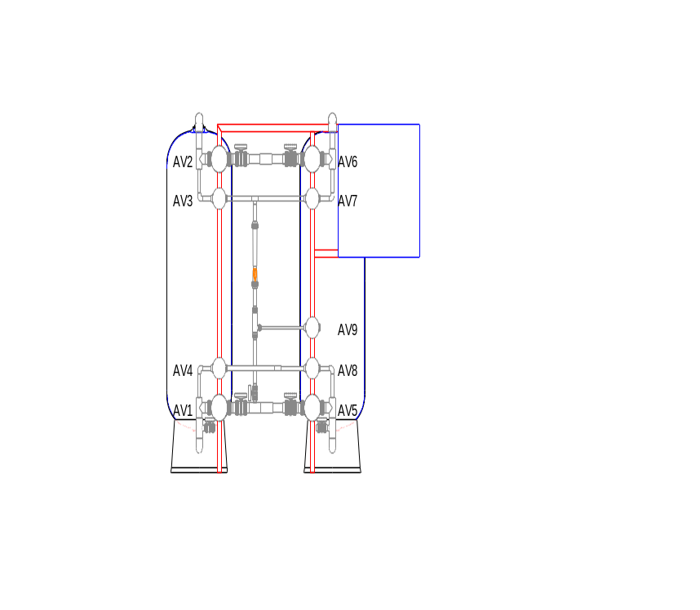

Technical data duplex softener
 |  | CSoft MV UFS D18 | CSoft MV UFS D21 | CSoft MV UFS D24 | CSoft MV UFS D30
Tech. spec’s / vessel
Tank diameter | mm | 457 | 533 | 610 | 762
Total tank height | mm | 1.880 | 1.760 | 2.010 | 2.040
Volume – total | L | 250 | 302,5 | 436,5 | 710
Filter media / vessel
Inert resins | L | 38 | 38 | 50 | 75
Bags of 25L
Monodisperse resins | L | 175 | 200 | 300 | 500
Bags of 25L
Support layer (1,7-2,5 mm) | kg | 25 | 50 | 75 | 100
Bags of 25kg
Flow rates
Qnom @1,0 bar dP | m³/h | 8,0 | 11 | 12 | 15
Qmax @1,5 bar dP | m³/h | 10 | 14 | 16 | 21
Exchange capacities / vessel
°F.m³ (5,5 °F.m³ per L resin) |  | 963 – 1.138 | 1.100 – 1.300 | 1.650 – 1.950 | 2.750 – 3.250
dH.m³ |  | 541 – 639 | 618 – 730 | 927 – 1.096 | 1.545 – 1.826
kg CaCO3 |  | 10 – 11 | 11 - 13 | 17 – 20 | 28 - 33
Regeneration
Salt consumption | kg | 15 | 18 | 26 | 44
Brine consumption | L | 51 | 59 | 88 | 147
Brine tank type | L | 200 |  | 300 | 400
Water consumption | m³ | 0,30 | 0,34 | 0,51 | 0,85
Connections
IN/OUT |  | DN40 |  |  | DN50
DRAIN |  | DN15 | DN20 |  | DN25
BRINE |  |  | DN15 |  | DN20
Approx. Dimensions Softener
Width | mm | 1.714 | 1.867 | 2.019 | 2.324
Depth | mm | 957 | 1.033 | 1.110 | 1.262
Height | mm | 2.380 | 2.260 | 2.510 | 2.540
Estimated operating weight | kg | 850 | 1.000 | 1.350 | 2.100
Dimensions Brine tank
Diameter | mm | 680 |  | 760 | 880
Height | mm | 830 |  | 1.000 | 920
Reference code |  | 4407055497 | 4407055498 | 4407055499 | 4407055500

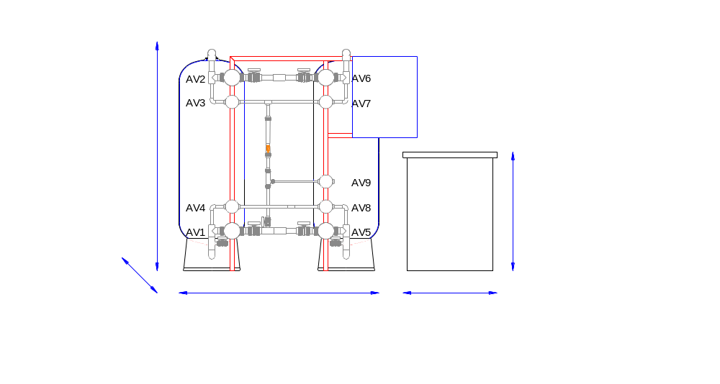

 |  | CSoft MV UFS D36 | CSoft MV UFS D42 | CSoft MV UFS D48 | CSoft MV UFS D55 | CSoft MV UFS D63
Tech. spec’s / vessel
Tank diameter | mm | 914 | 1.067 | 1.219 | 1.397 | 1.600
Total tank height | mm | 2.350 | 2.430 | 2.465 | 2.681 | 3.270
Volume – total | L | 1.020 | 1.360 | 1.840 | 2.619 | 4.265
Filter media / vessel
Inert resins  Bags of 25L | L | 125 | 150 | 175 | 325 | 325
Resins  Bags of 25L | L | 725 | 950 | 1.275 | 1.650 | 3.000
Support layer (1,7-2,5 mm)  Bags of 25kg | kg | 175 | 275 | 425 | 750 | 1.025
Flow rates
Qnom @1,0 bar dP | m³/h | 21 | 34 | 43 | 44 | 53
Qmax @1,5 bar dP | m³/h | 30 | 47 | 55 | 59 | 74
Exchange capacities / vessel
°F.m³ (5,5 °F.m³ per L resin) |  | 3.988 – 4.713 | 5.225 – 6.175 | 7.013 – 8.288 | 9.075 – 10.725 | 16.500 – 19.500
dH.m³ |  | 2.240 - 2.647 | 2.935 – 3.469 | 3.940 – 4.656 | 5.098 – 6.025 | 9.270 – 10.955
kg CaCO3 |  | 40 – 47 | 52 – 62 | 70 – 83 | 91 – 107 | 165 - 195
Regeneration
Salt consumption | kg | 64 | 84 | 112 | 145 | 264
Brine consumption | L | 213 | 279 | 374 | 484 | 880
Brine tank type | L | 750 |  | 1.000 | 1.750 | 2.500
Water consumption | m³ | 1,24 | 1,62 | 2,17 | 2,81 | 5,12
Connections
IN/OUT |  | DN65 | DN80 |  | DN100
DRAIN |  | DN32 |  | DN40 | DN50
BRINE |  | DN20 |  | DN25 |  | DN32
Dimensions Softener
Width | mm | 2.629 | 2.934 | 3.238 | 3.594 | 4.000
Depth | mm | 1.414 | 1.567 | 1.719 | 1.897 | 2.100
Height | mm | 2.850 | 2.930 | 2.965 | 3.181 | 3.770
Estimated operating weight | kg | 2.950 | 3.900 | 6.500 | 7.500 | 11.900
Dimensions Brine tank
Diameter | mm | 1.030 |  | 1.100 | 1.300 | 1.420
Height | mm | 1.120 |  | 1.290 | 1.500 | 2.060
Reference code |  | 4407055501 | 4407055502 | 4407055503 | 4407055504 | 4407055505

Control box

System
The system consists of two vessels with an identical effect.
The control of the installation consists of one electric box with HMI (human-machine interface), a main switch and an alarm. The pin code for this control box = 4444. Only authorised persons should have this pin code.

The following chapters deal with the creation and use of the HMI for the total system.

Plant cycles
The system has two cycles, service and regeneration. The regeneration exists also of four cycles. This is the same for both vessels, but may be programmed differently where necessary.
For each step in the cycle, the valves will be switched in a different way. This may be set up in the HMI for each step, the duration of each step can be set freely as well.
Service:
During the service one fixed valve position is used. One of the two vessels shall carry out the service while the other is in regeneration or ‘stand-by’. Only during the ‘stand-by’ of one of the vessels, the second vessel may automatically come into service if an extremely high flow rate is requested and detected at the outlet. This may be programmed.
During normal operation, the duration of the service is determined by the volume of treated water that is supplied at the outlet of the system together with a quality check. Once this volume has been reached, or if the quality control has carried out a third unfavourable reading, the second cycle will be activated, i.e. the regeneration of the device that was in service. The other device will start working automatically.
It is possible to switch to regeneration in a different way:
- After a number of days following the previous regeneration.
- At a fixed time.
- Manually.
The regeneration
The regeneration consists of three steps:
- Step 1: Brine, slow rinse
- Step 2: backwash
- Step 3: Brine refill
If the regeneration is started, the other vessel switches immediately from ‘stand-by’ to service.
First phase: brine and slow rinse
During the first 10 minutes of step one the electric conductivity is monitored. Subsequently, the average is calculated and recorded for step three. The following step (slow rinse) is started after the brine from the brine bin has been fully absorbed. The transfer to step 2 only takes place after the set time. If in step 1 the electric conductivity on the outlet does not reach a ‘set point’, an alarm is activated. Salt alarm.
Phase 2: backwash.
If during step 2 the conductivity drops below the average EC value increased by a set value, step 3 is activated immediately. If this situation does not occur, the step continues until the set time has expired.
Phase 3: Brine refill.
Once step 3 has been taken, another valve position is maintained until the time has expired. During this time, the system makes just sufficient water flow back into the brine bin to dissolve the required quantity of salt. Subsequently, the ‘stand-by’ is switched on.

Control box
The control box for the high performance softener is located in the direct vicinity of the softener. Figure 1 shows the control box.
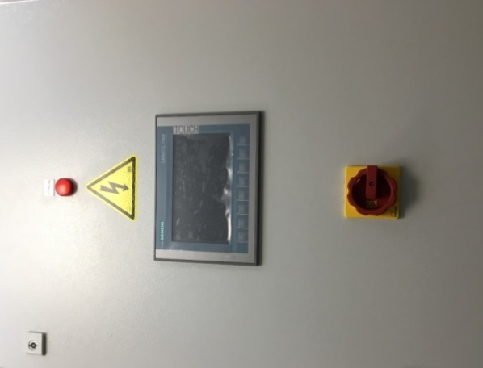
Figure 1

The following parts are on the control box:
- Red light: indication of an activated alarm.
- HMI: visualisation of the system.
- Main switch: to safely switch off the system.
On the system the following digital sensors are used:
- Compressed air detection
- Water pulse counter on the inlet
- Water pulse counter on the outlet
- Float for releasing the 6th valve
- Brine bin float to protect the brine pump
The following analogue sensors are used as well:
- Pressure meter inlet
- Pressure meter outlet
- Electric conductivity meter

HMI – touch screen

Information Hydris
The info page contains general information regarding Hydris. Figure 2 shows this screen.
Each screen has a menu bar on the left hand side for navigating between the various screens. Moreover, touch buttons are located at the bottom of the screen which correspond with the menu bar. The top button on the menu bar is the left button of the touch buttons at the bottom of the screen.
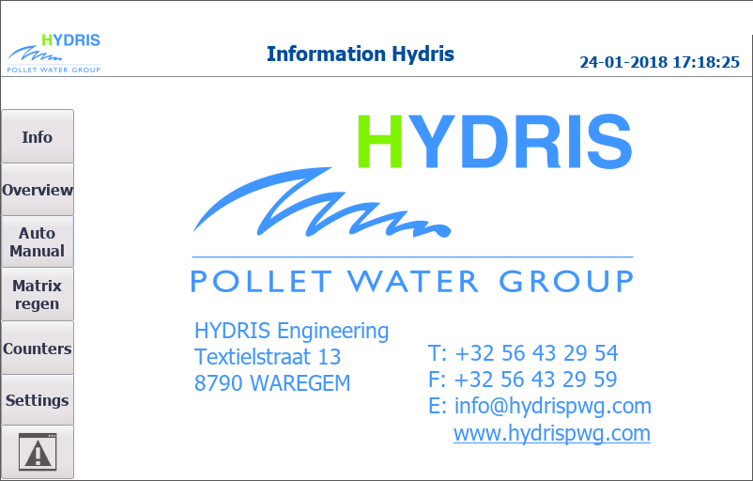
Figure 2

Overview
In the overview screen all valves are displayed as balls, which become green when they are opened. At the inlet and outlet the pressure and flow rate are displayed. The step the system is operating in and the time the last service was started per vessel are displayed on the right.
To the left of this, the EC reading on the outlet is displayed:
- The actual value
- The average value after 10 minutes in the first step of regeneration.
- The value at which the second step of the regeneration stops.
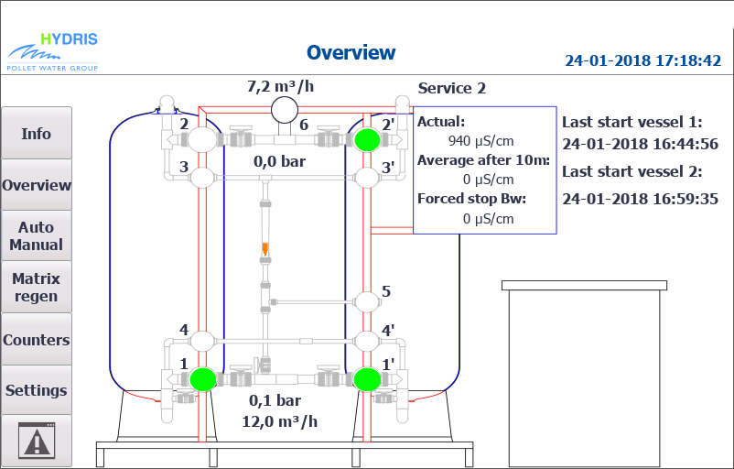

Automatic/manual
In automatic mode the system can be switched manually to the other vessel and start the regeneration for vessel 1 or vessel 2. The step in which the system is operating and how long it has been active is displayed at the bottom as well. In Figure 4 the automatic mode is shown.

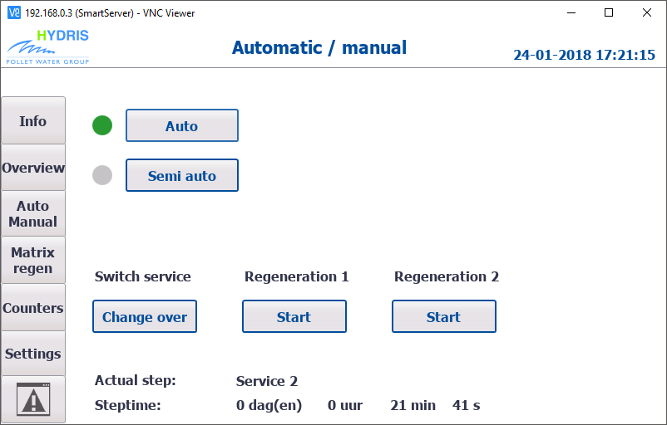
Figure 4

When a switch to semi-automatic mode is made, a manual switch may be made to the following step, in order to test the operation or skip a step. In manual control, care should be taken that brine cannot flow to the consumers. The semi-automatic mode is shown in Figure 5.

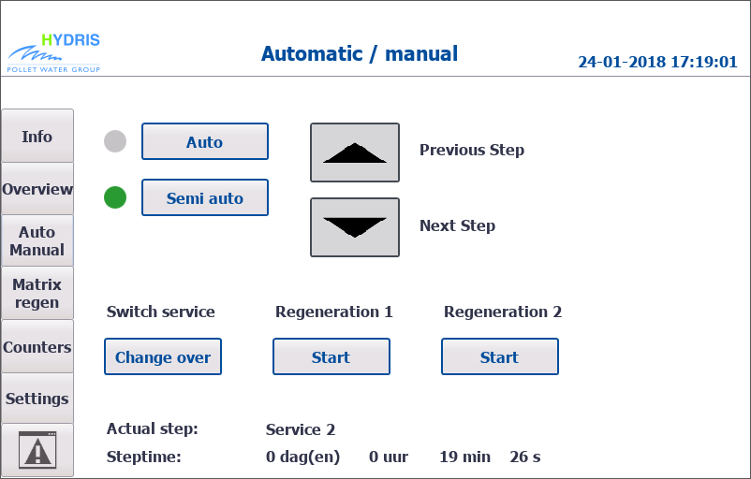
Figure 5

Matrix regeneration
In this screen, the matrix with the valve positions can be adjusted. For each step the system goes through, the valve that needs to be switched may be set. The max. duration of the activation of this step can also be set. For the service this is based on outgoing volume. For the other steps this is on a time basis. The screen is shown in Figure 6.
The step can be adjusted by first selecting the step. When it turns green, the values of the selected step may be adjusted. This should all be carried out or adjusted by qualified employees.

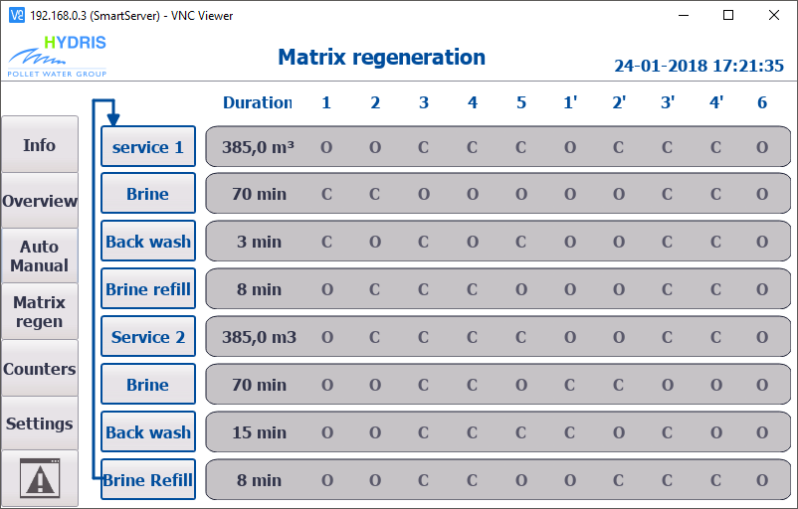
Figure 6

Counters
The counter screens show counters and logging. Moreover, general information about the system is displayed.
The first screen (Figure 7) displays the step information and time, comparable to the screen on semi-automatic operation. Below are the following counters:
- Volume to be processed before vessel 1 must regenerate.
- Volume to be processed before vessel 2 must regenerate.
- Total volume outlet. (Only to be reset by the manufacturer)
- Volume outlet for the present day. (Only to be reset by the manufacturer)
- Total volume inlet. (Only to be reset by the manufacturer)
- Volume outlet for the present day. (Only to be reset by the manufacturer)
- Difference between volume inlet and outlet: the regeneration volume

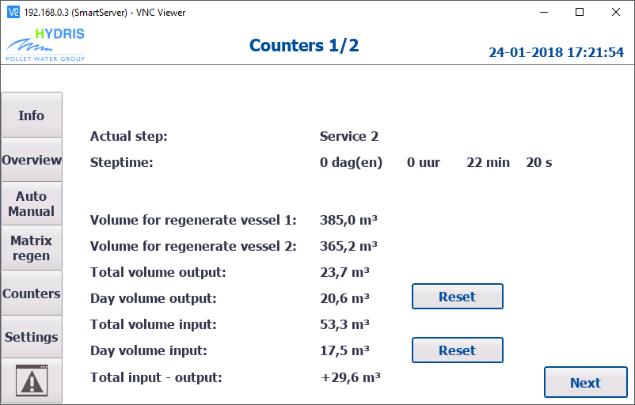
Figure 7

The second screen (Figure 8) displays the historic data. These are always the ten last values. The most recent value is displayed at the top and will move down.
The first table shows the water consumption during regeneration. This is the difference in volume between the inlet and outlet between the start of the regeneration and the end of the backwash.
The second table shows the outlet volume of the last services.
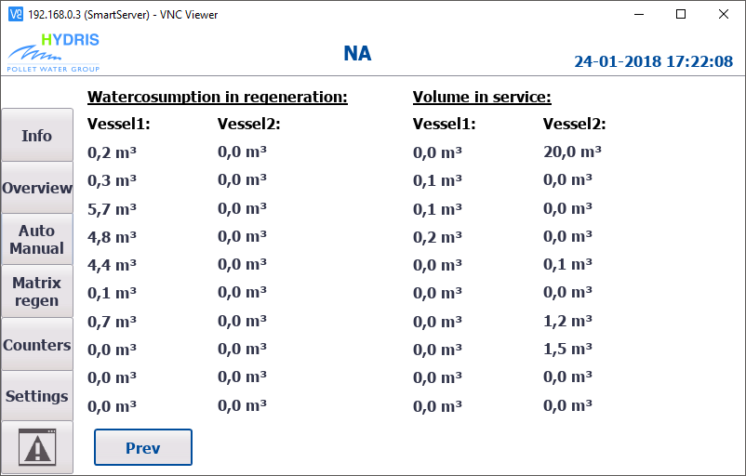
Figure 8

Settings
The first partial screen (Figure 9) displays general settings:
- Maximum pressure differences between inlet and outlet (display alarm).
- Volume for detection high flow rate (activating both vessels).
- Volume for detection low flow rate (activating recirculation pump).
- Minimum pressure at inlet (display alarm).
- Hardness of supplied water for automatic calculation of capacity.
- Exchange capacity for calculating total capacity.
- Volume of resin for calculating capacity.
- Choice of reaction to salt alarm (stopping cycle or proceeding).
- Setting of PLC time.

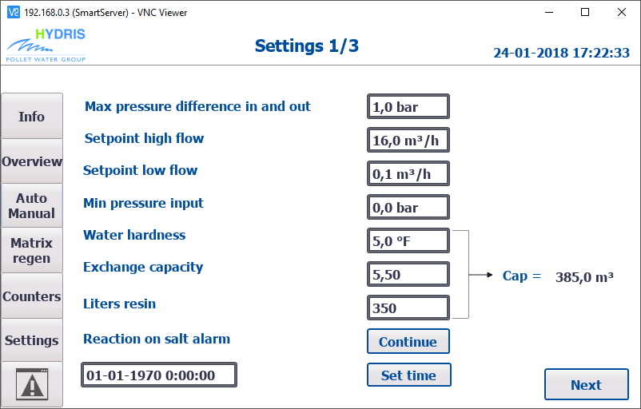
Figure 9

The second partial screen (Figure 10) displays settings regarding regeneration:
- Minimum achieved conductivity during the first step of the regeneration (otherwise salt alarm).
- A value that is increased with the average value of the first 10 minutes. If the EC drops below this EC in the second step (backwash), the system shall switch to the third step (brine refill) of the regeneration immediately.
- Delay on signal of hardness meter to start regeneration.
- Minimum hours between two regenerations on the basis of hardness meter.
- Switching on/off of regeneration at a certain time.
- Switching on/off of regeneration on a timed basis.

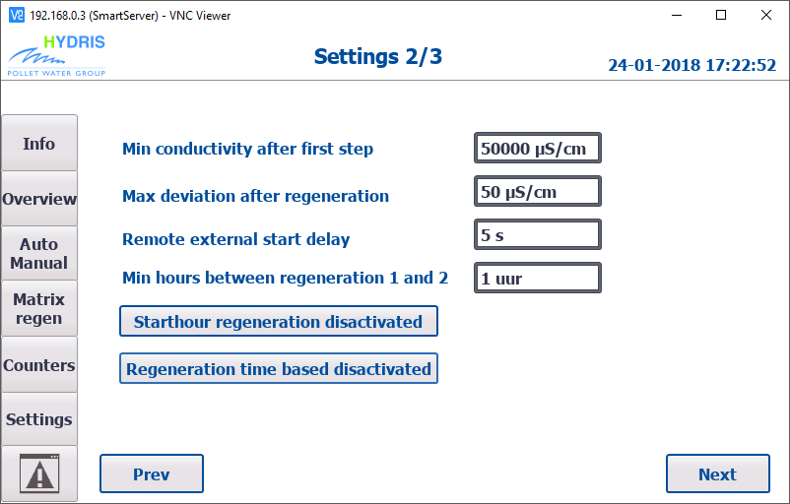
Figure 10

If the last two settings are activated, extra fields will appear. This has been indicated in Figure 11.
If regeneration is activated at a starting time, a field with hours and minutes appears. If a regeneration is required, it will start at this time. This is a delayed regeneration with immediate exchange of vessels.
If regeneration on a timed basis is activated, it is possible to fill in the number of days. A forced regeneration will only start after this number of days. The field underneath counts down the number of hours to the forced regeneration. This may be adjusted where required.

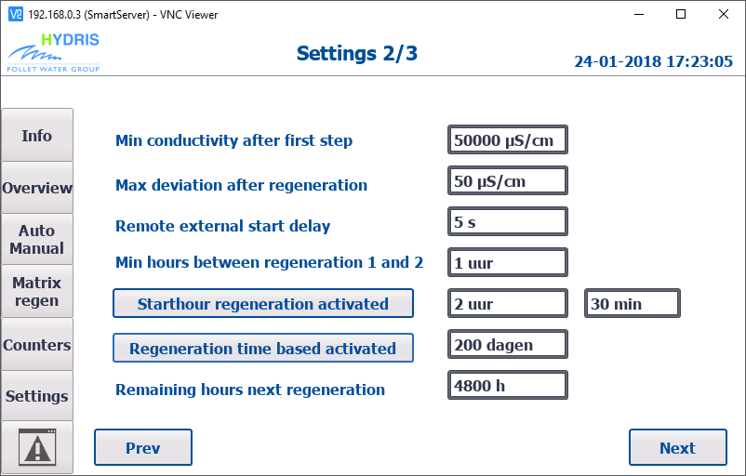
Figure 11

The last partial screen (Figure 12) displays settings regarding the sensors:
- Scaling pressure sensor at inlet (4 - 20mA).
- Scaling pressure sensor at outlet (4 - 20mA).
- Scaling conductivity reading (4 – 20mA).
- K value impulse water meter inlet (option - so may be switched off).
- K value impulse water meter outlet.

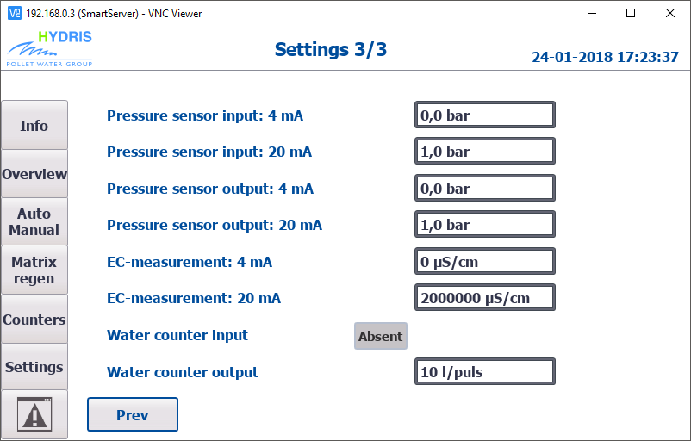
Figure 12

Alarms
This screen displays the alarms that are active on the system. The time and date when the alarm has occurred is displayed along with a brief description. Figure 13 shows an example of an alarm. Bottom right is a reset button to reset the alarms after the cause has been removed. Some alarms are reset automatically after the problem has been resolved.

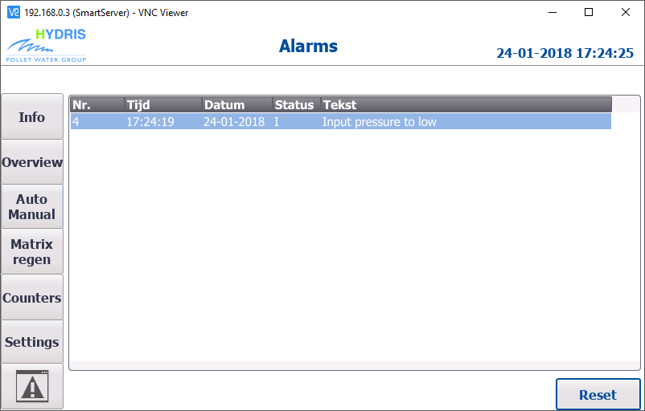
Figure 13

Table 1 gives an overview of the various alarms that may occur. The cause and the necessary action are displayed below as well.
No | Description | Cause | Solution
1 | Error compressed air | No pressure detected on valve terminal. | Check the compressed air connection and pressure.
2 | Salt alarm | Minimum conductivity during regeneration is not achieved. | Check if there is sufficient salt in the brine bin.  Clean the EC meter.  Clean the injector.
3 | Pressure difference in - output | Pressure difference not correct according to setting. | Check the consumed flow rate, is it not too high for this installation?  Check any pumps and connections. Check the pressure meters.
4 | Input pressure too low | Pressure not high enough according to setting | Check the inlet pressure, the pumps and connections.  Check the pressure sensor.
5 | Sycon 2800 asks for regeneration too soon | Hardness meter requests regeneration if the time of regeneration has not yet finished. (according to setting) | Check hardness meter Sycon 2800 and the full system.
Table 1

Electrical circuit diagram

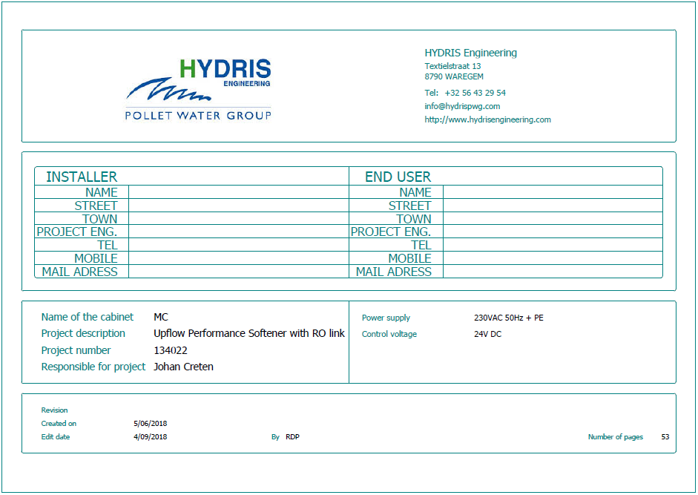

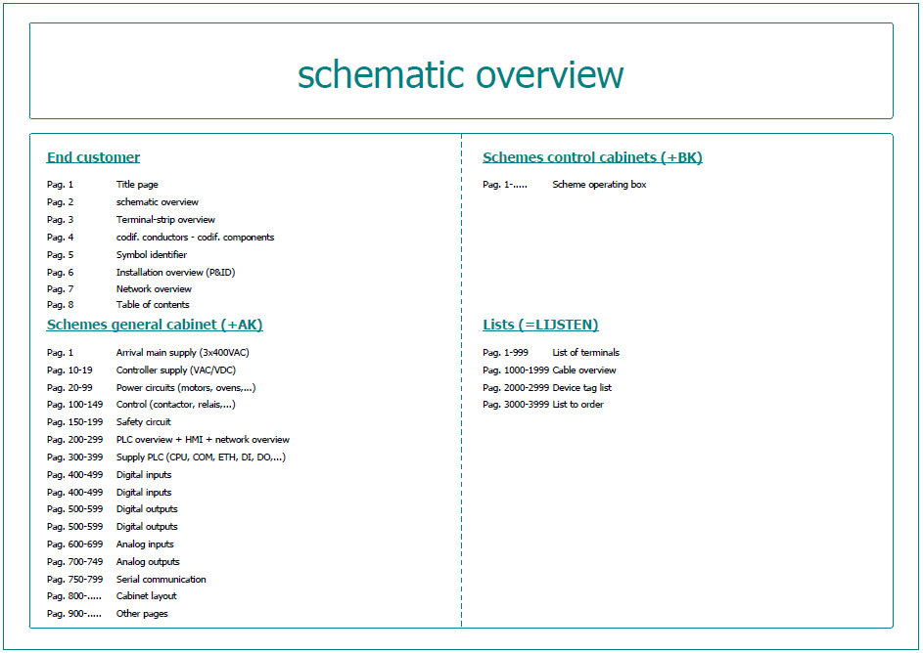

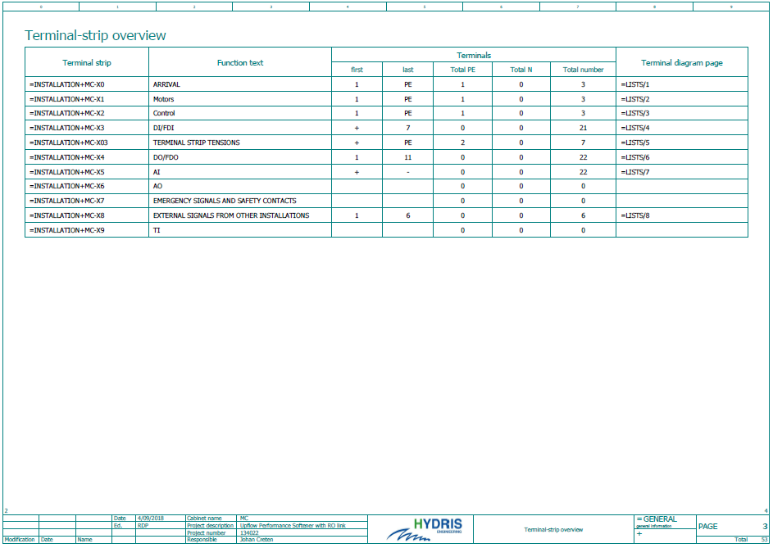

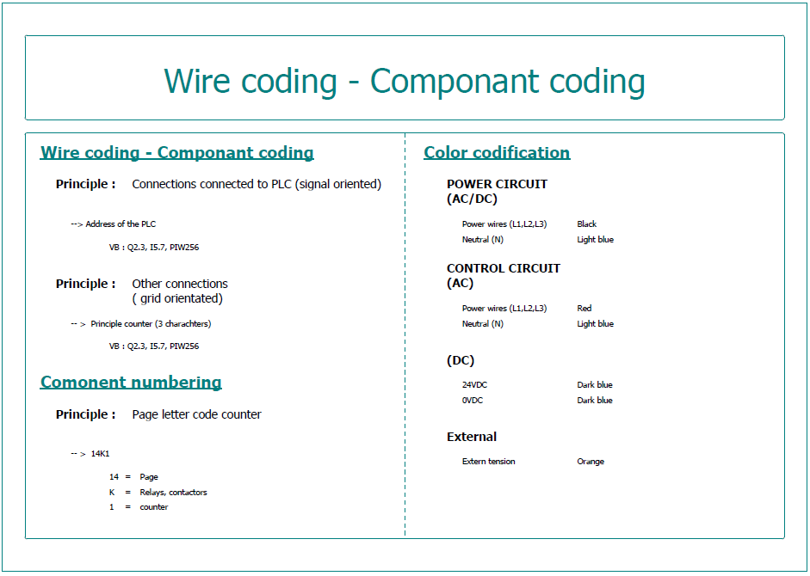

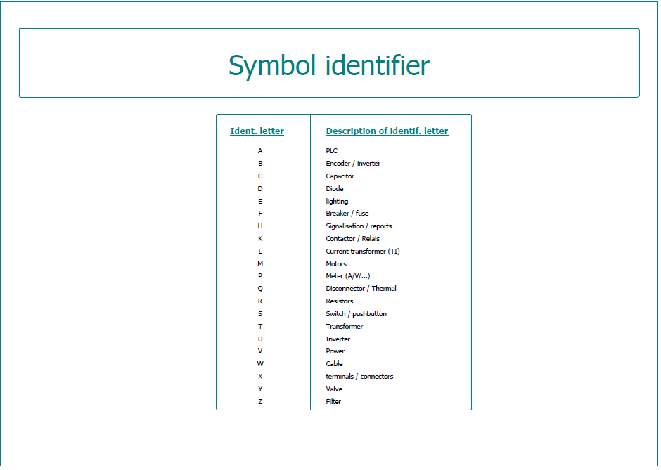

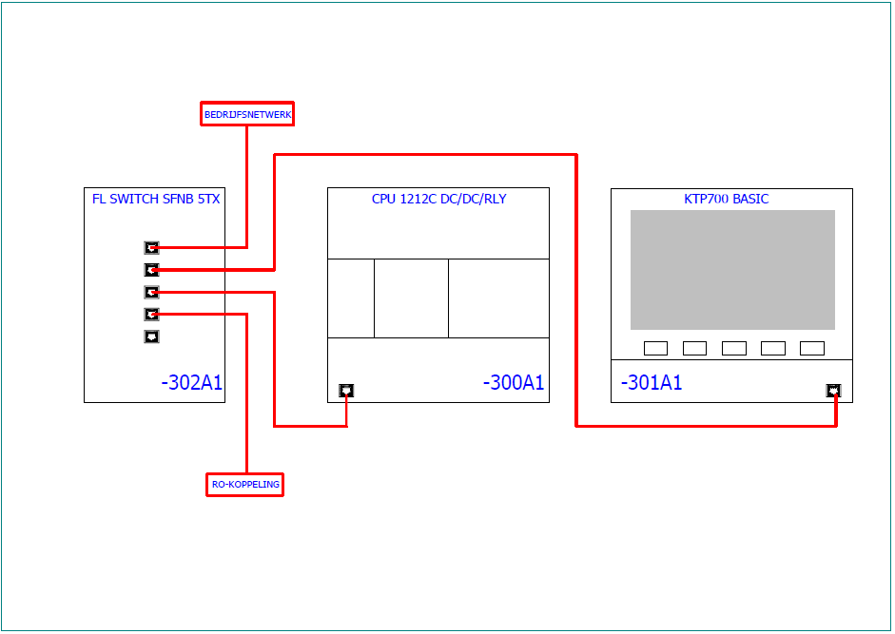

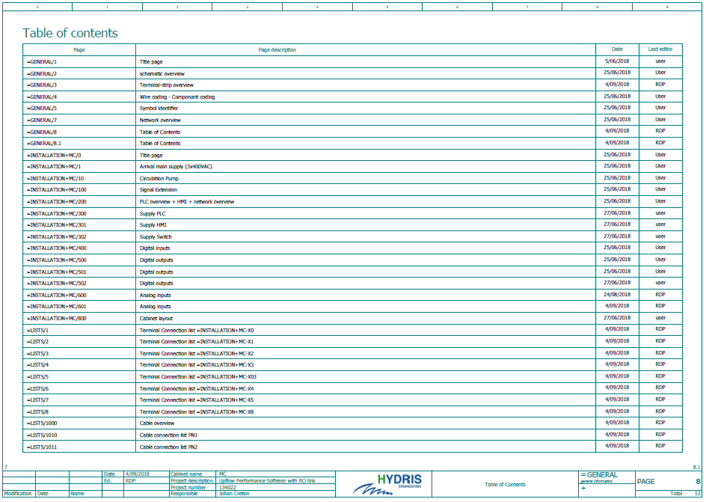

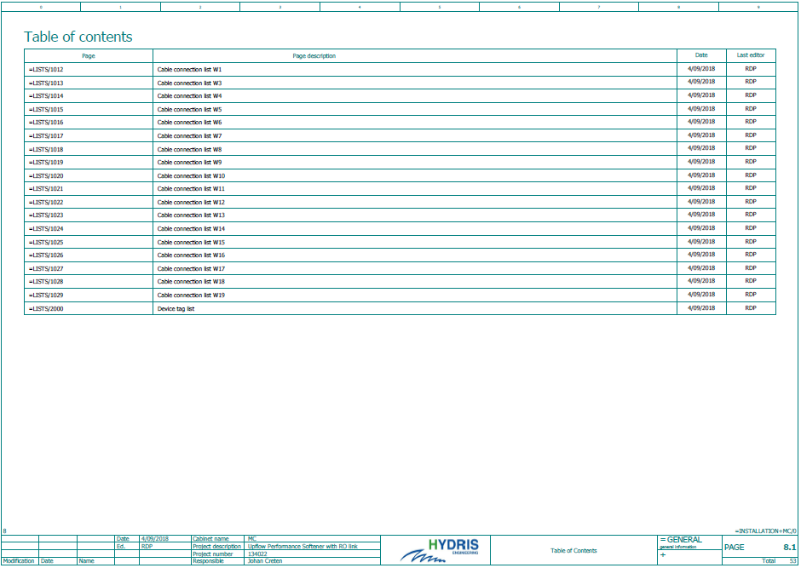

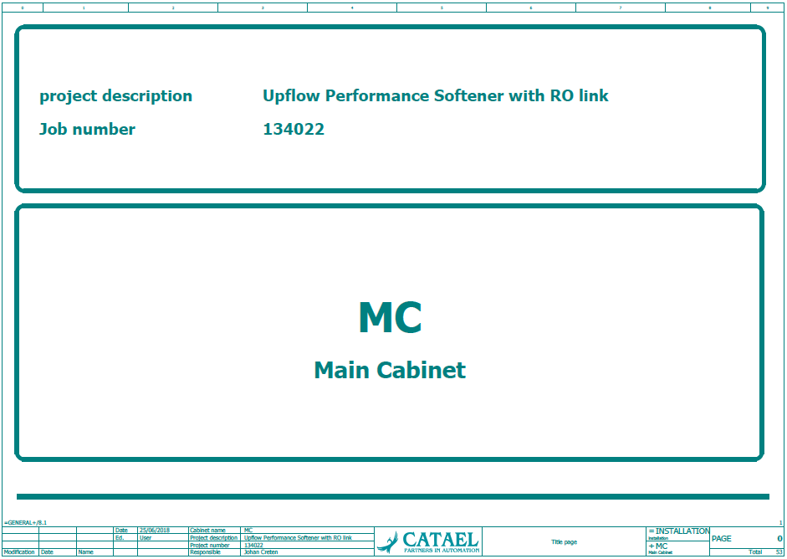

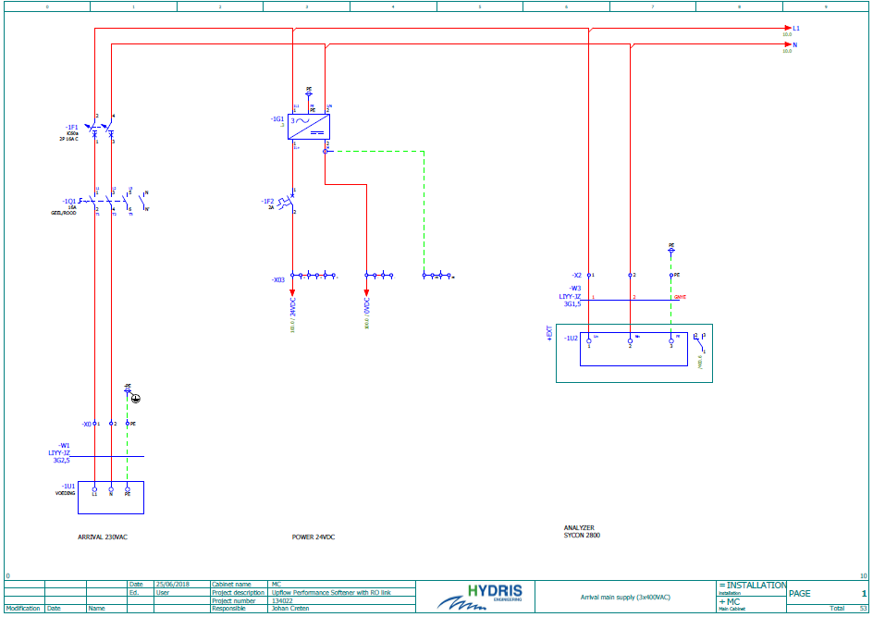

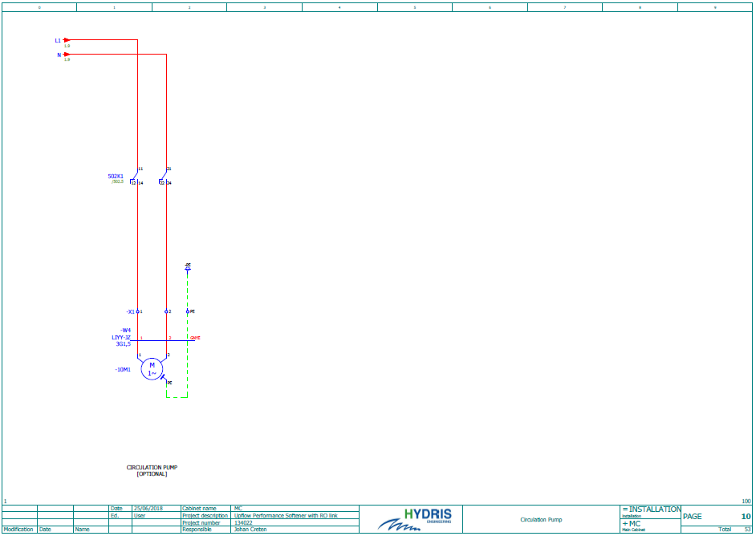

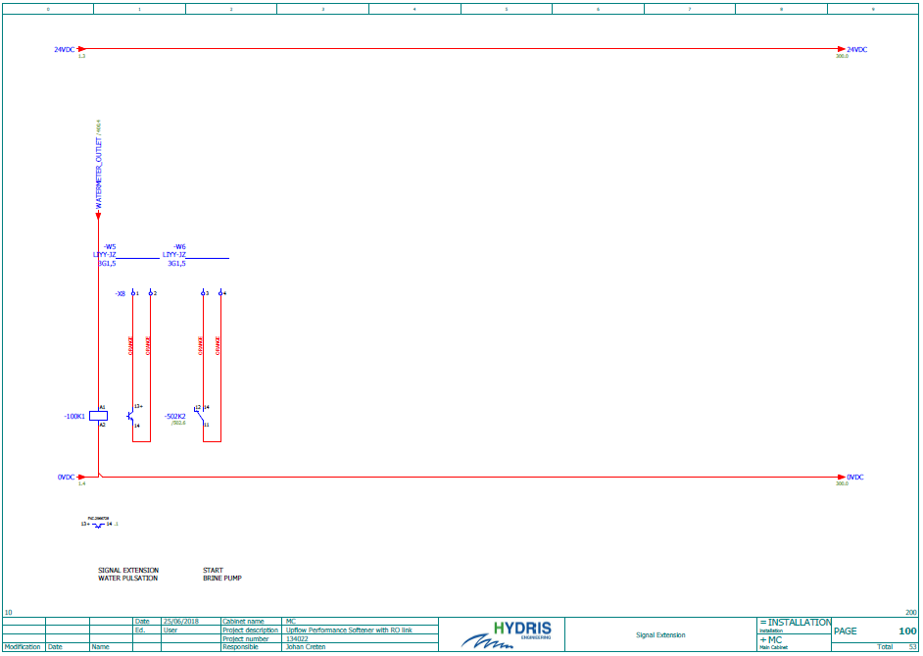

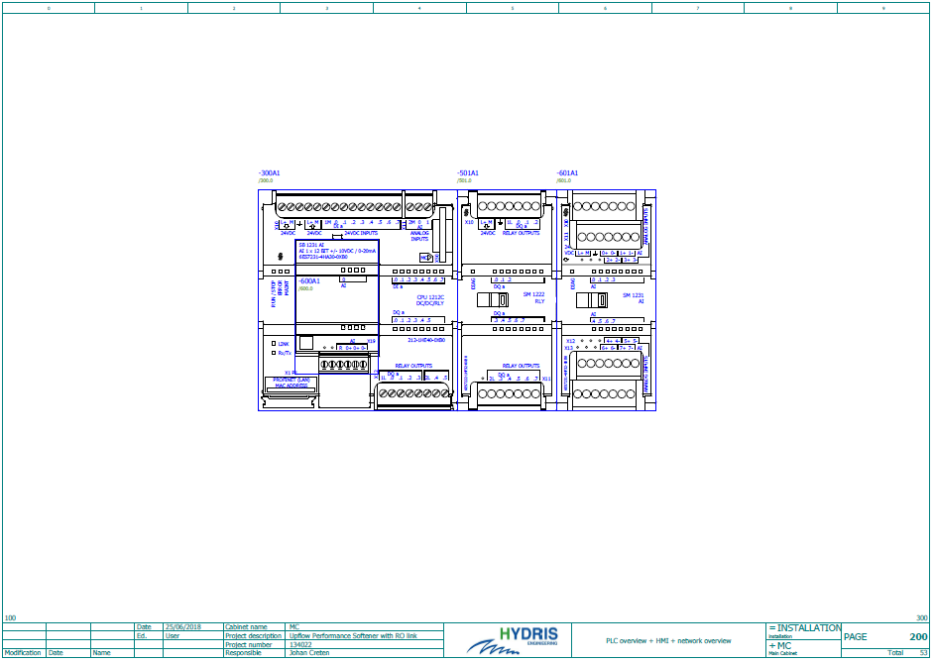

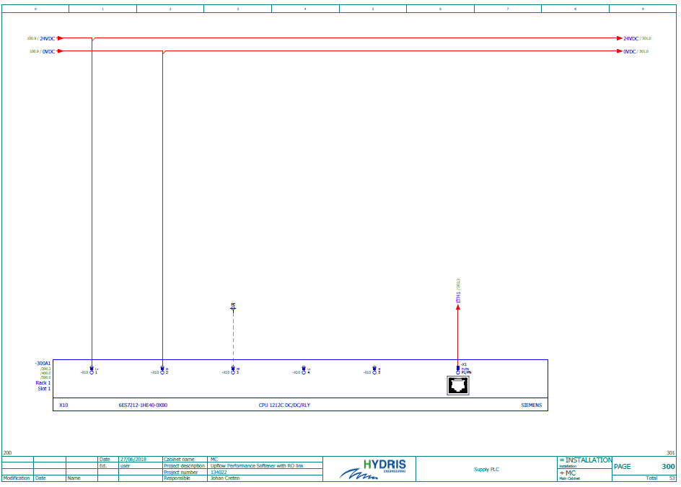

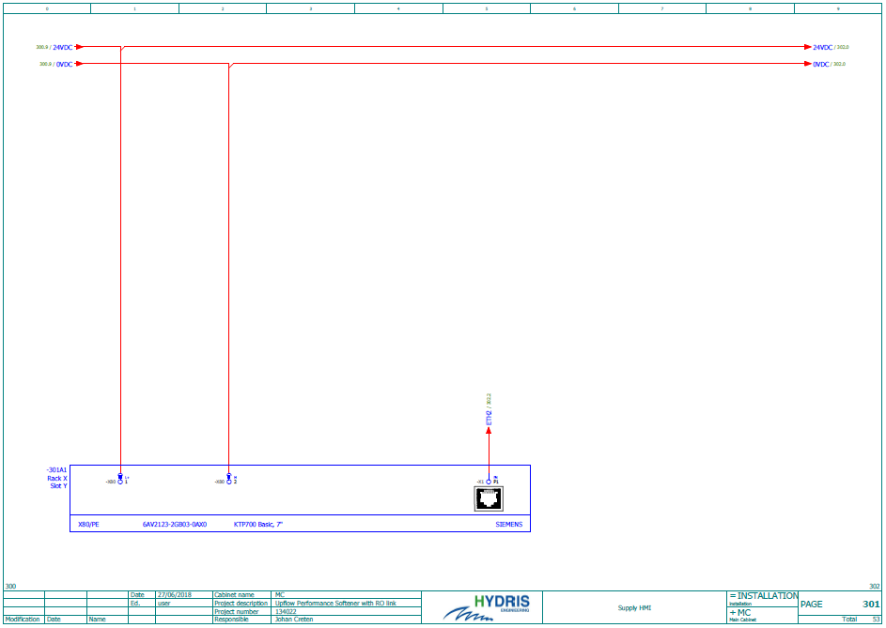

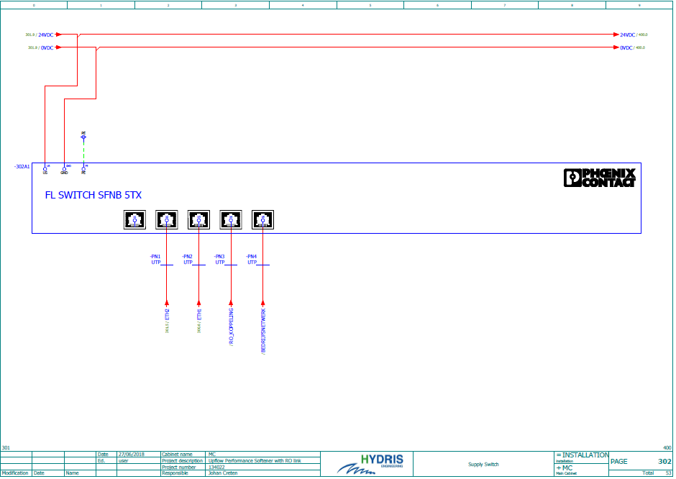

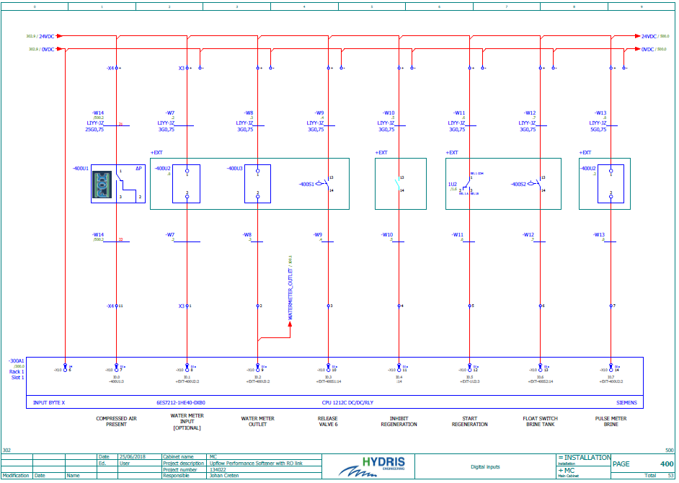

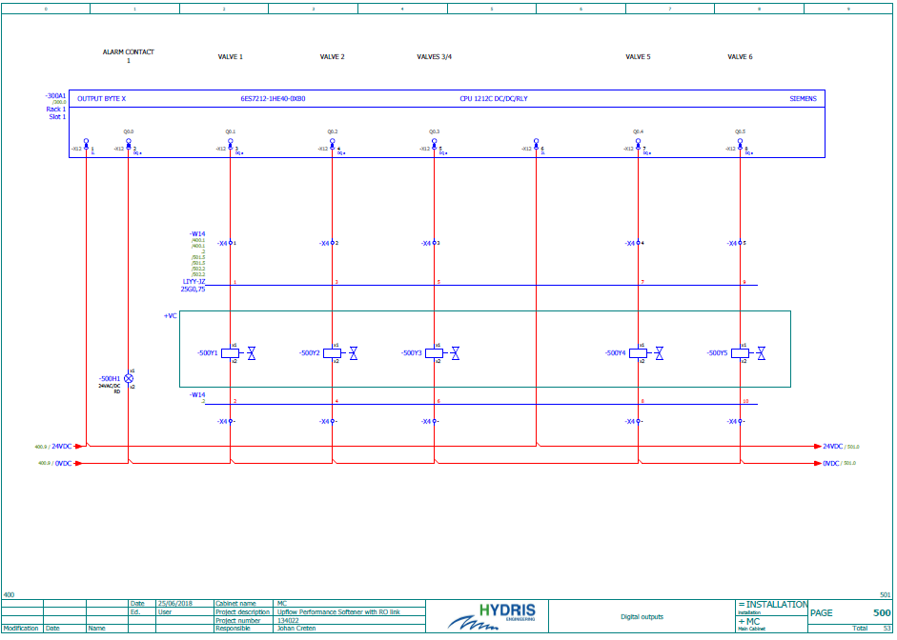

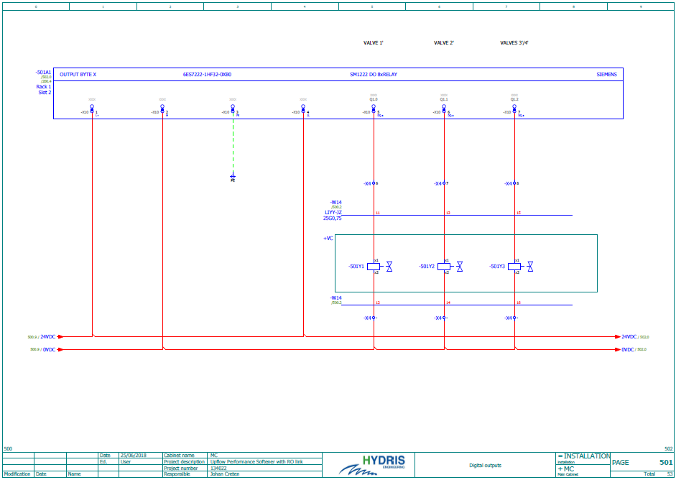

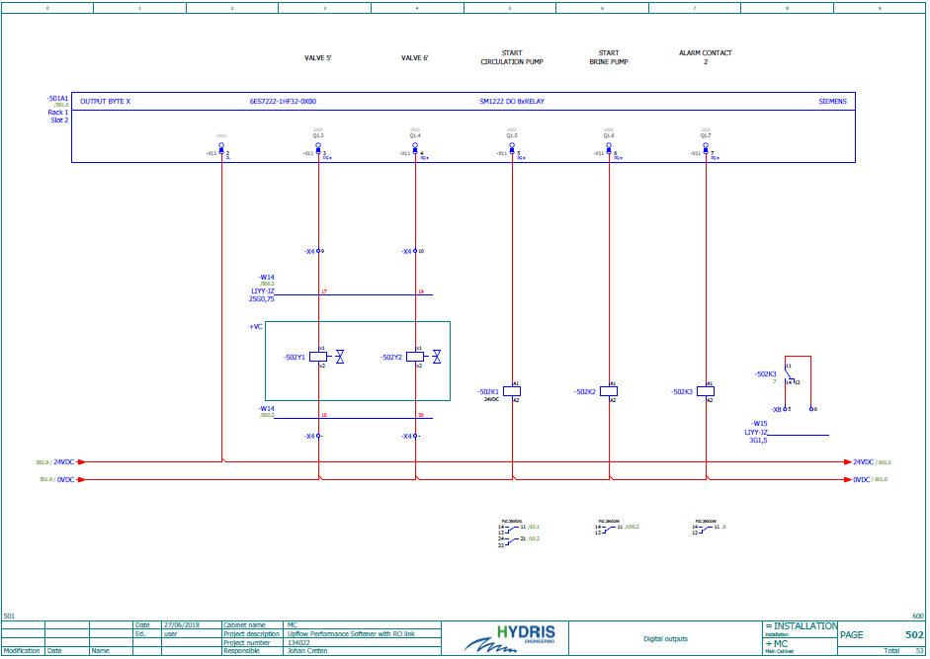

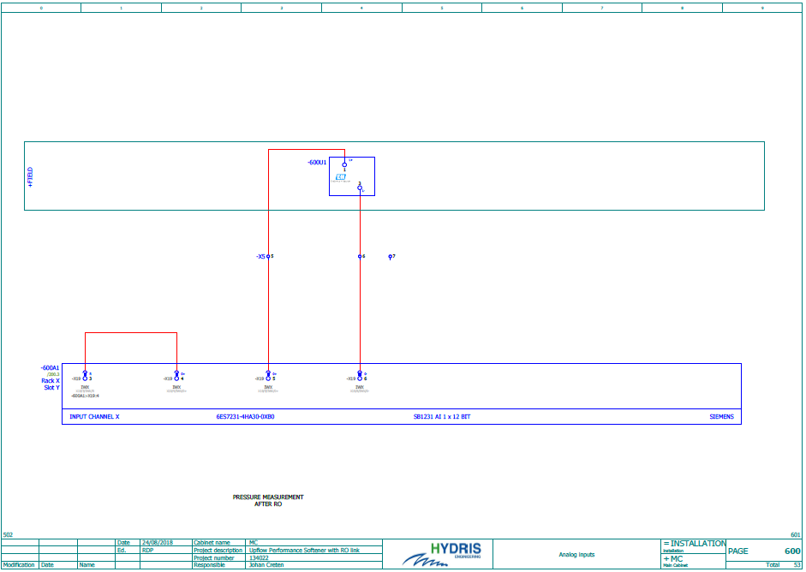

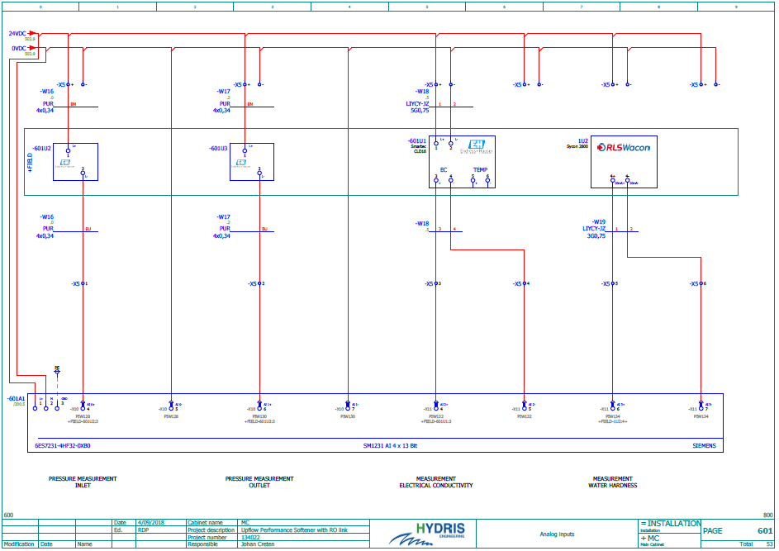

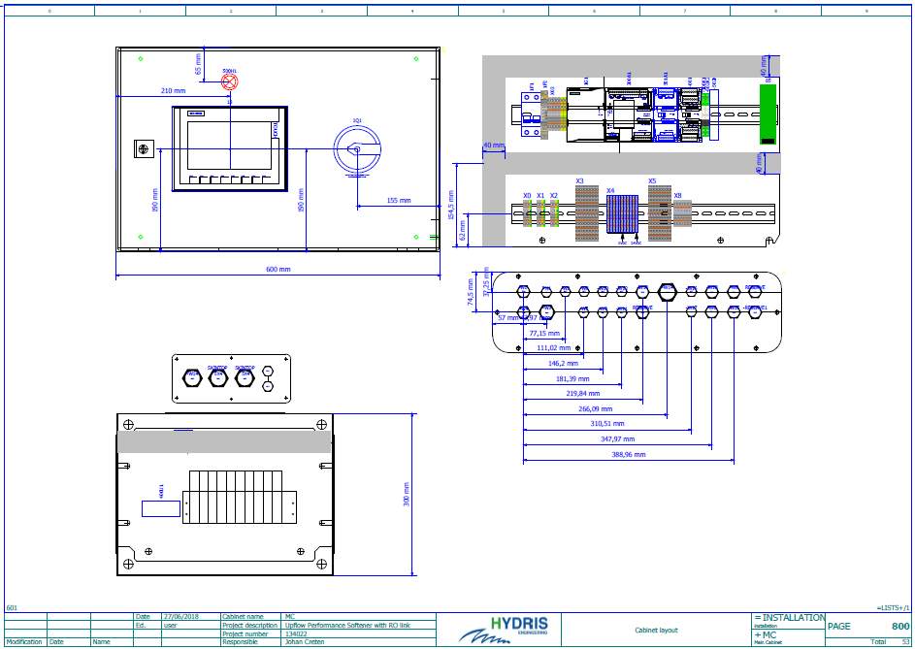

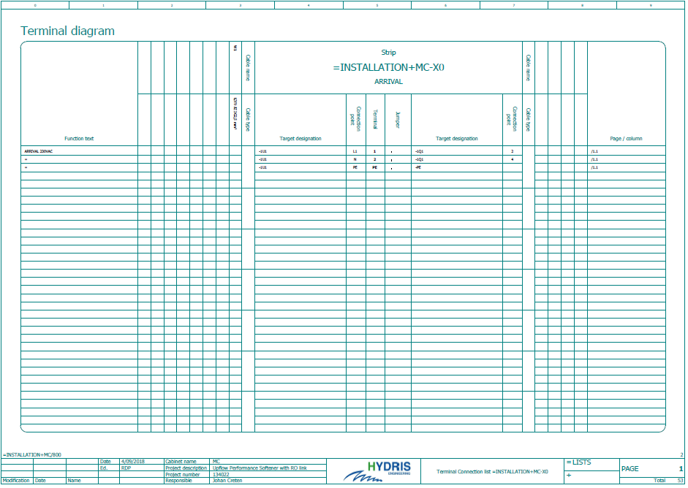

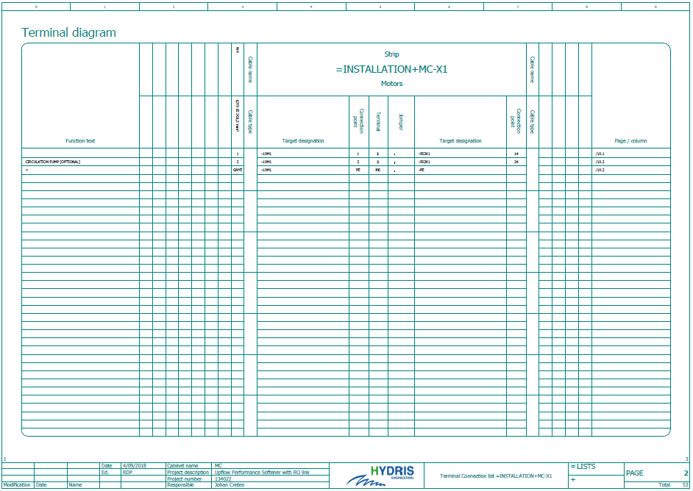

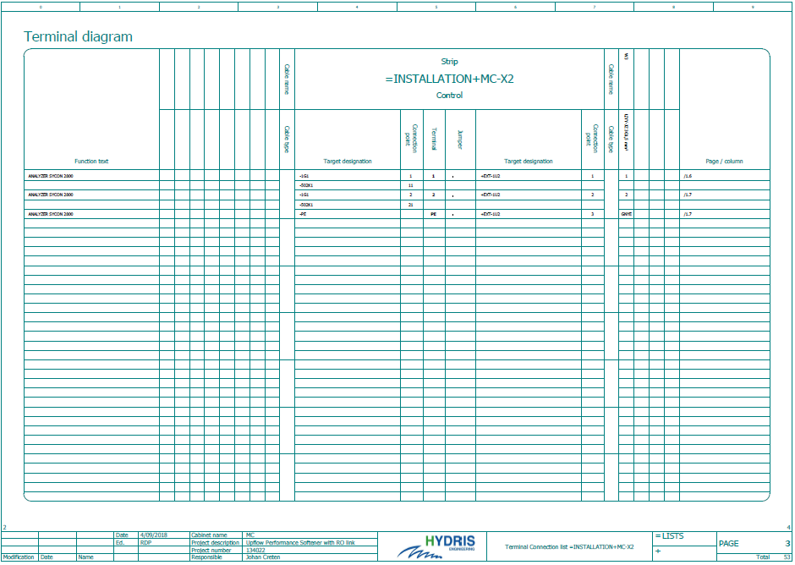

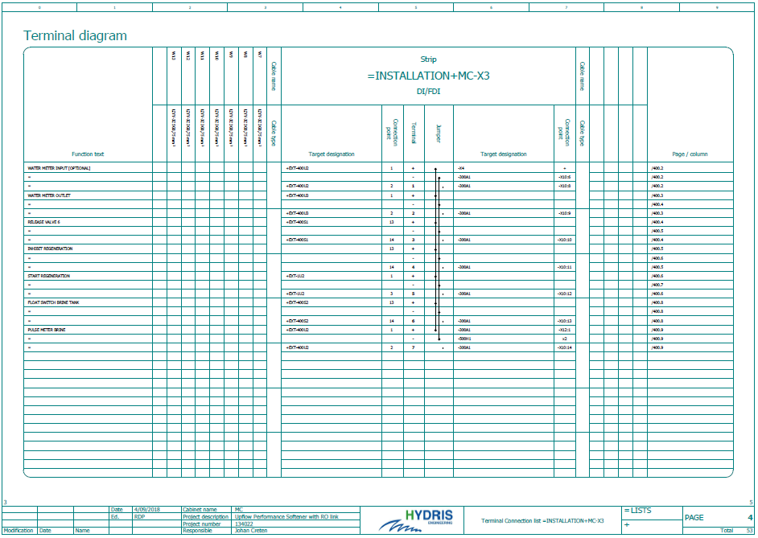

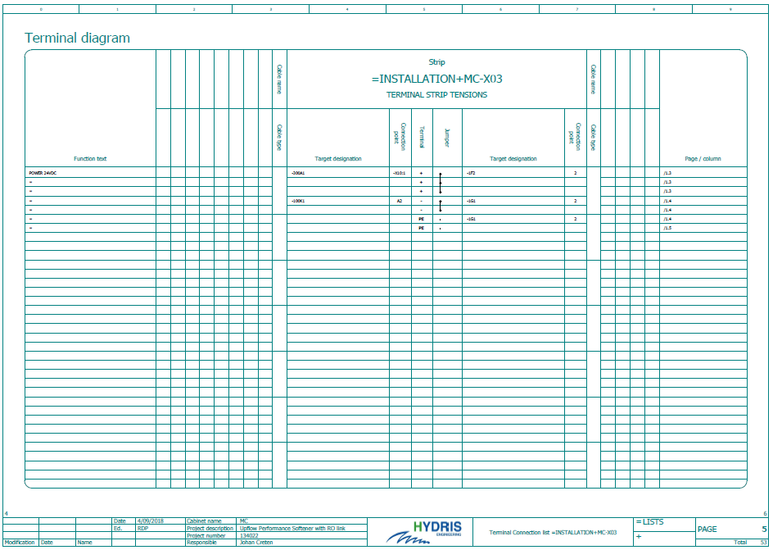

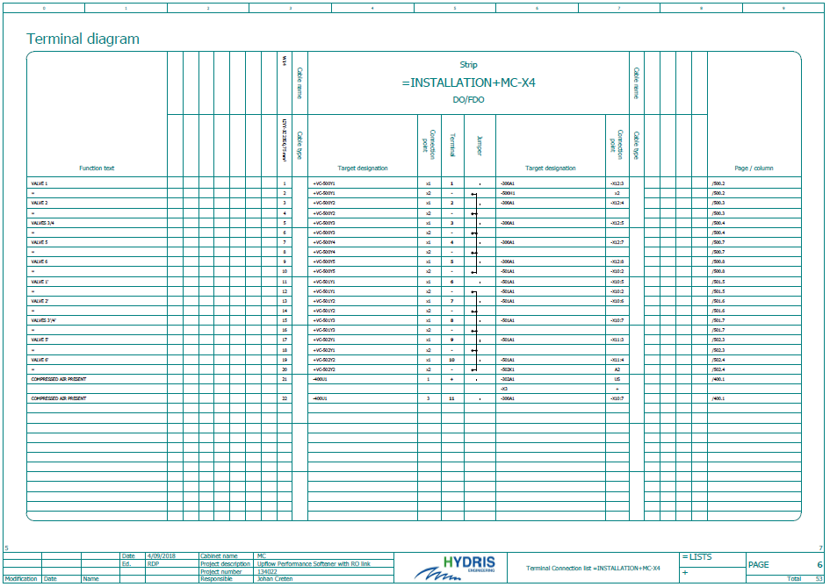

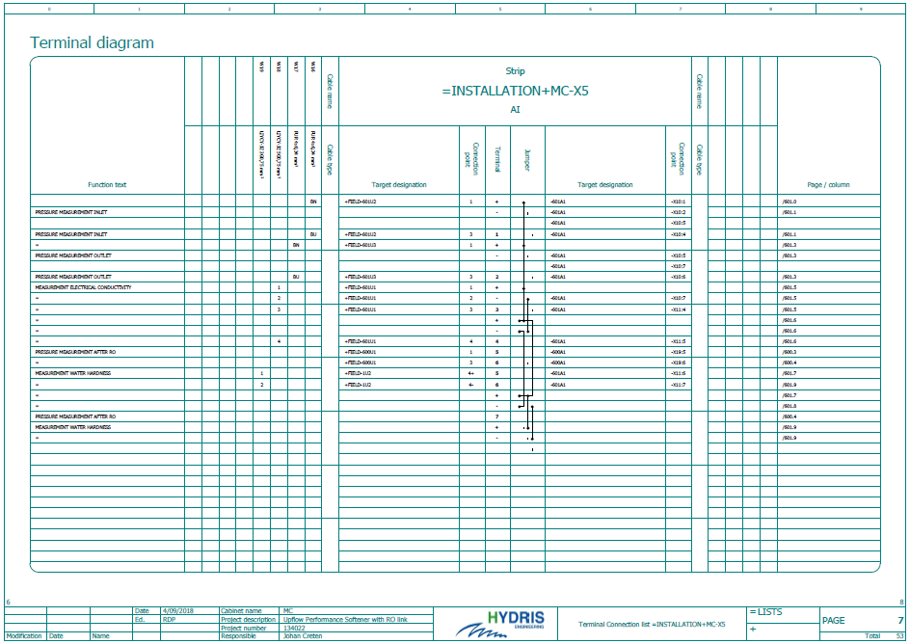

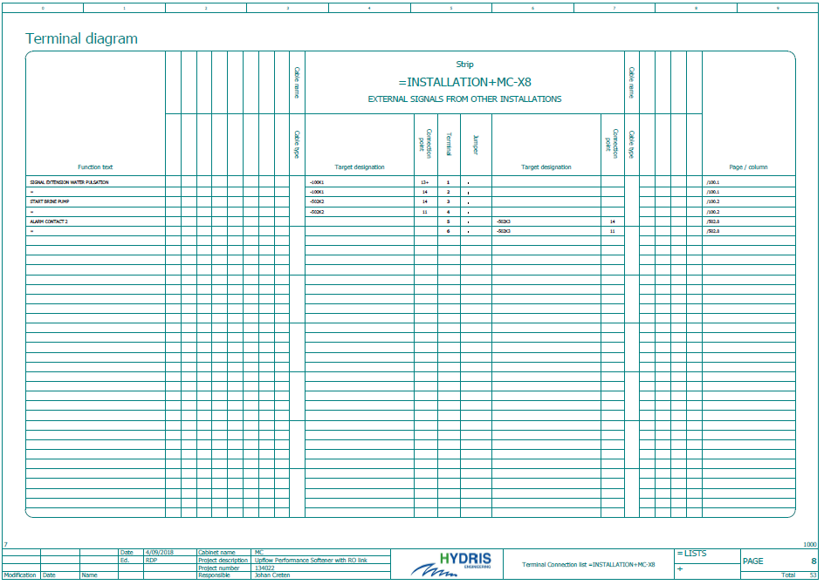

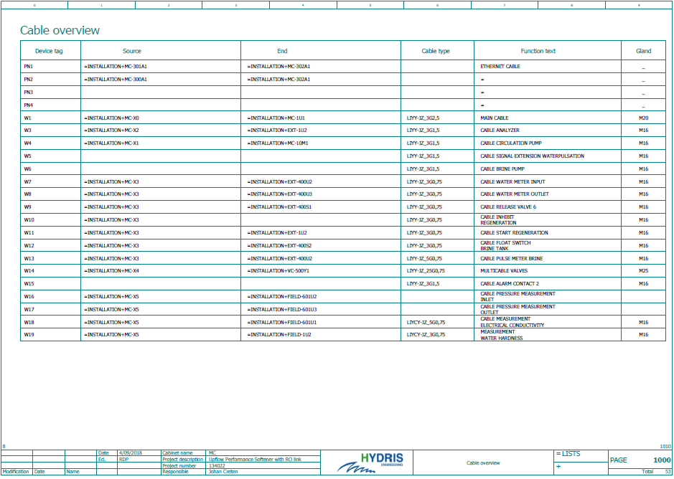

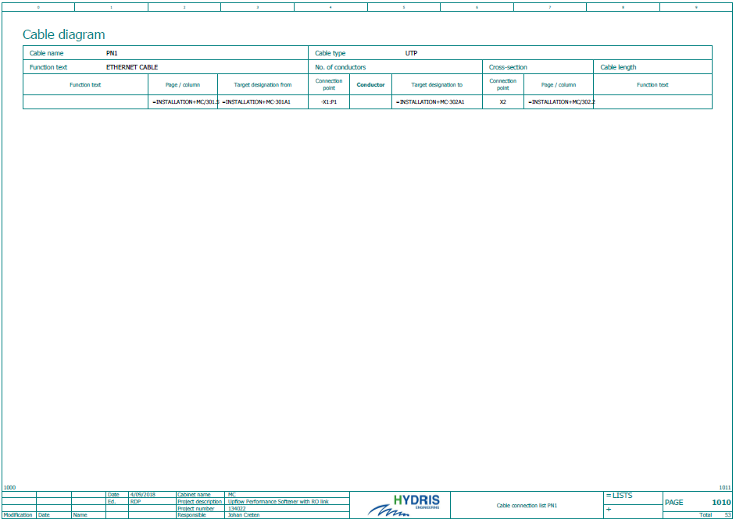

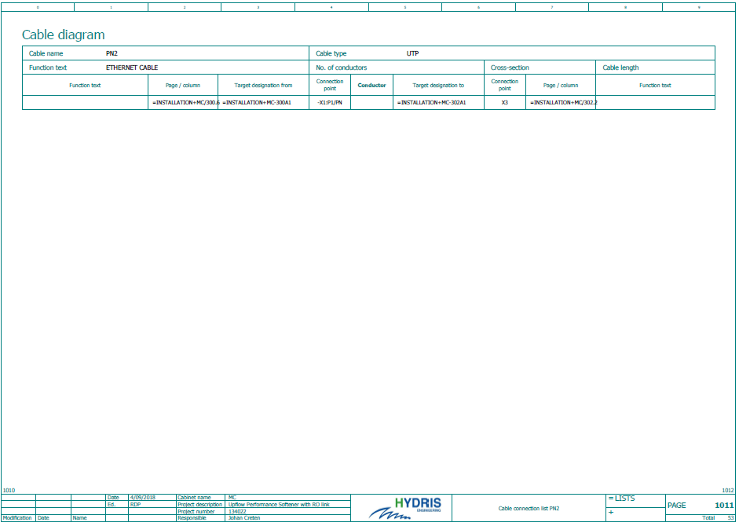

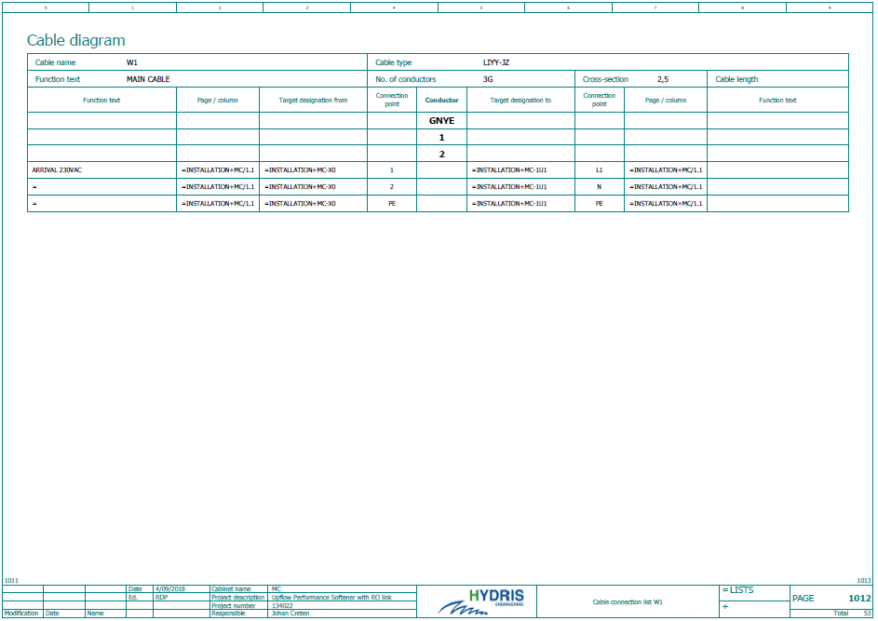

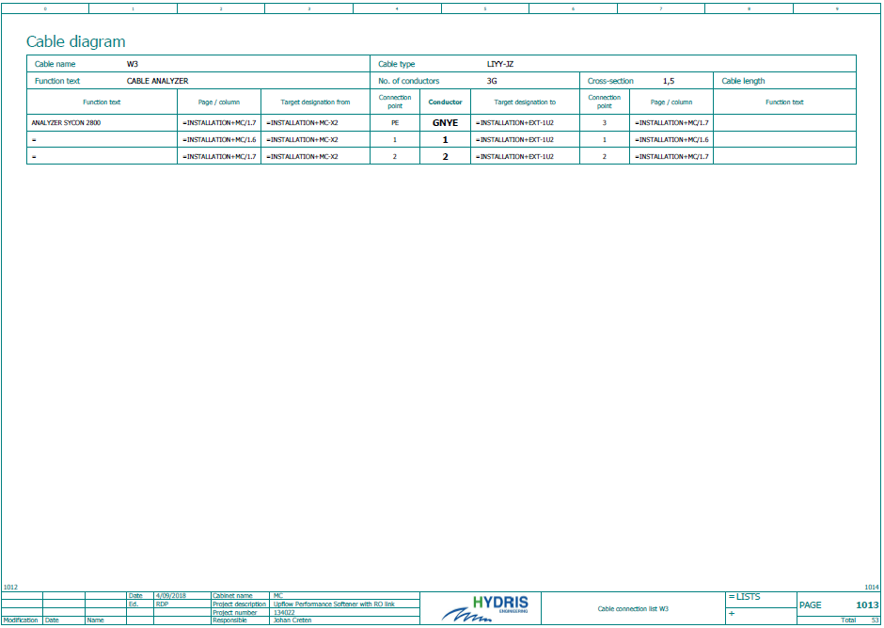

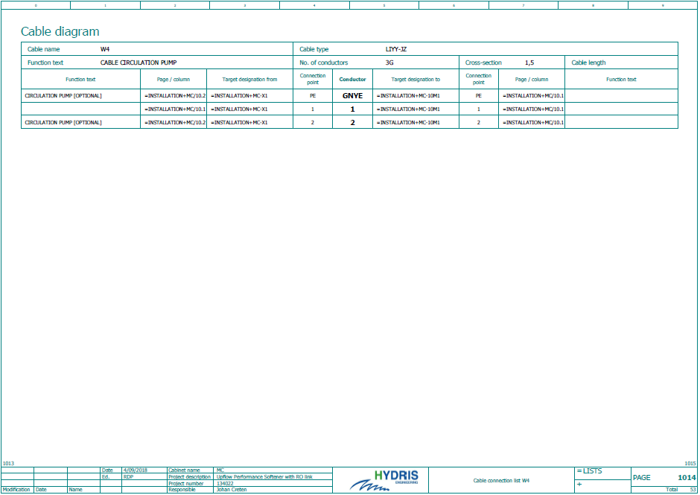

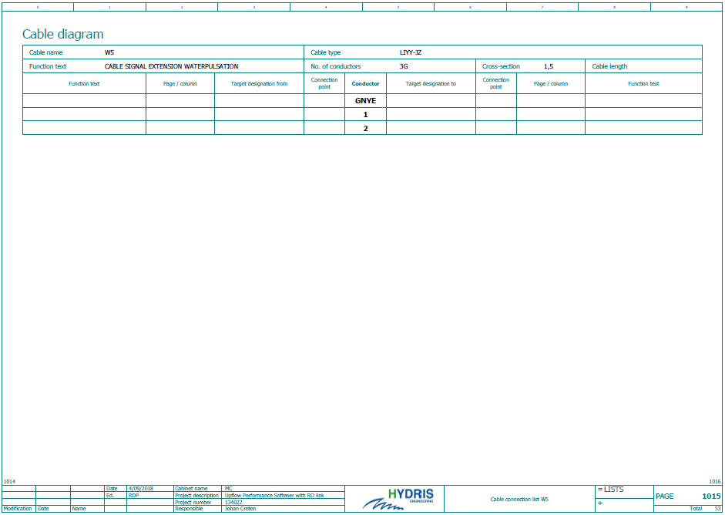

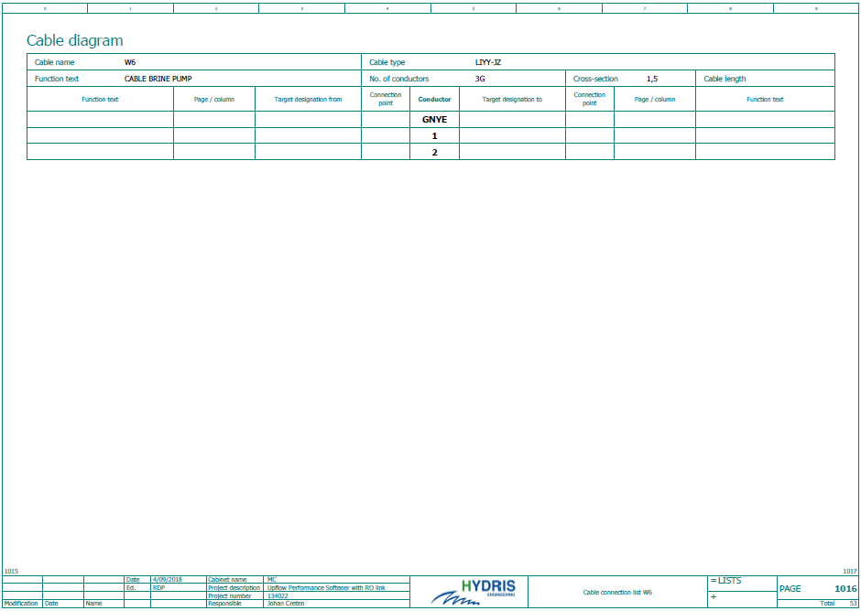

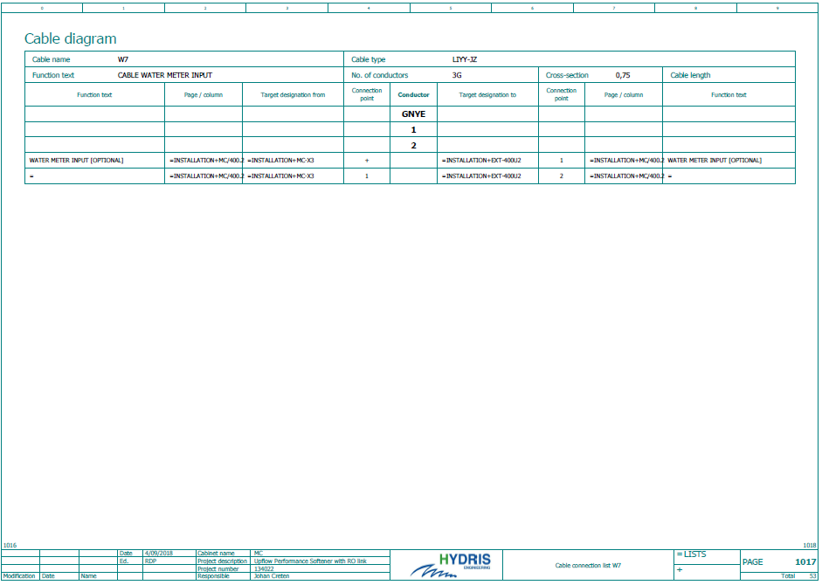

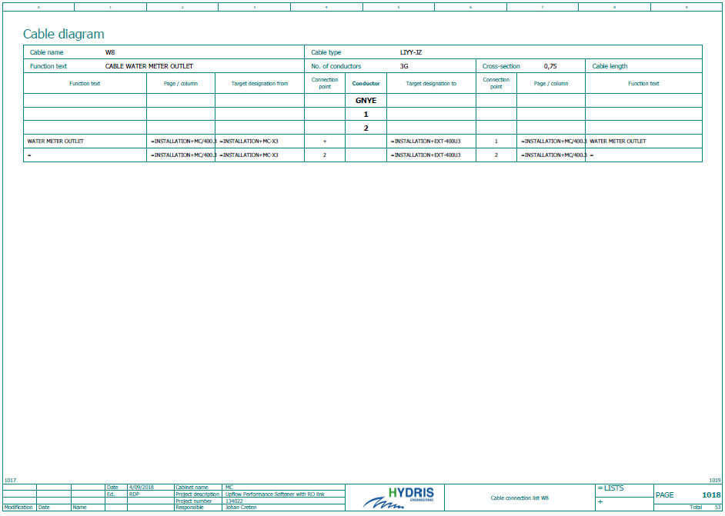

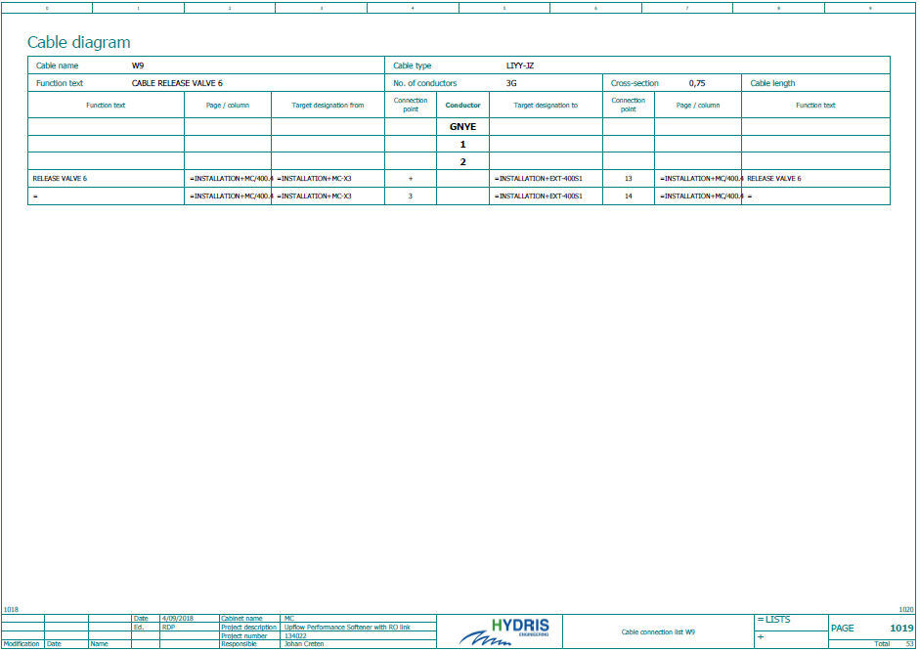

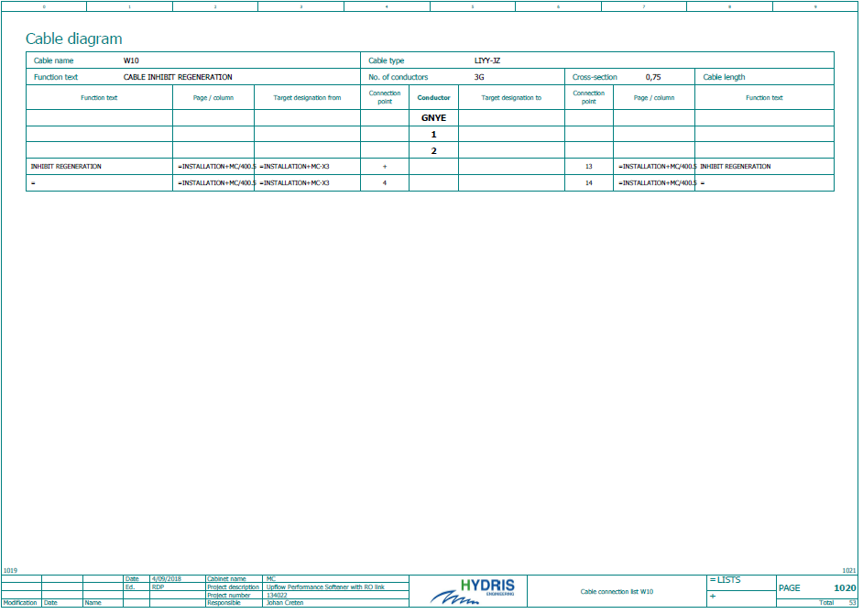

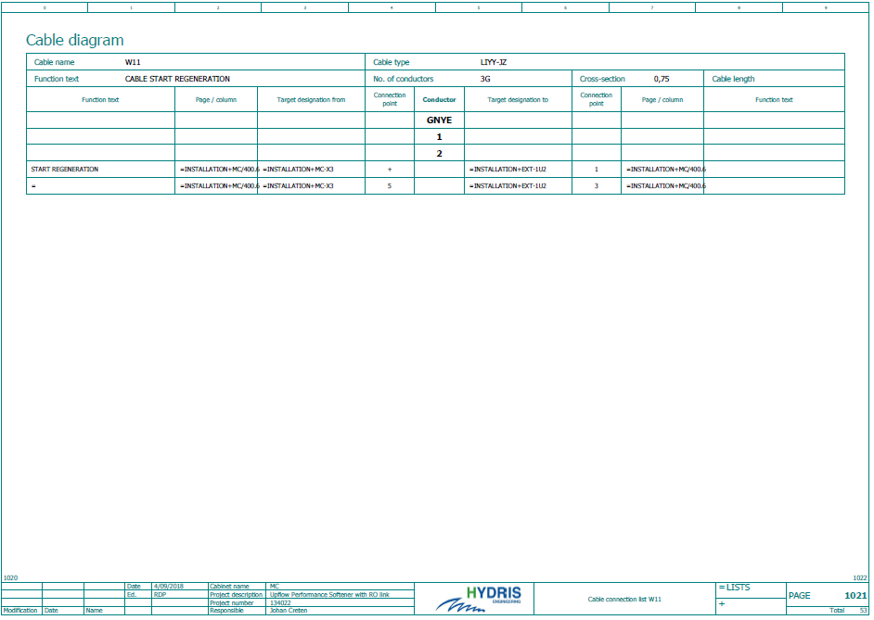

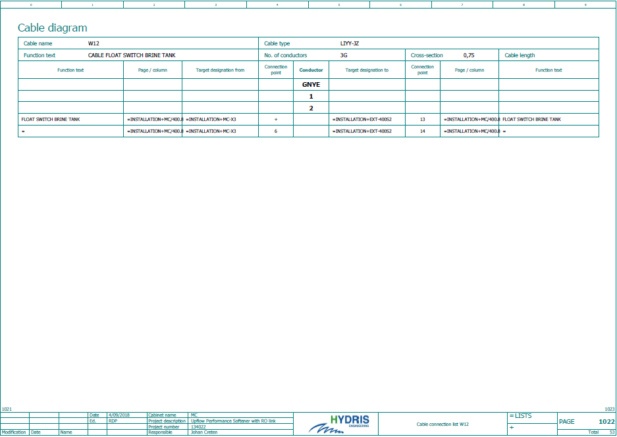

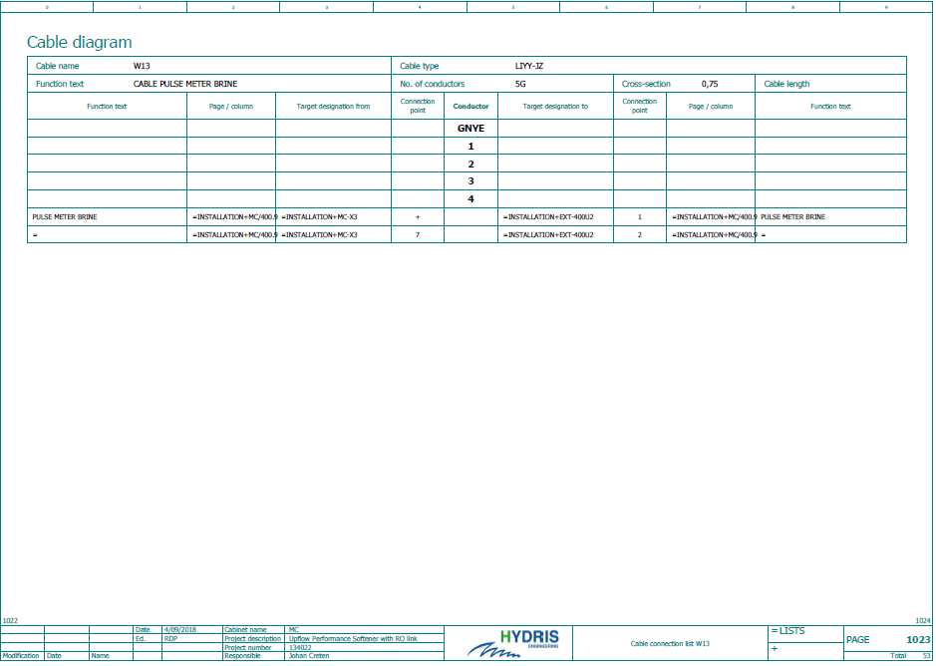

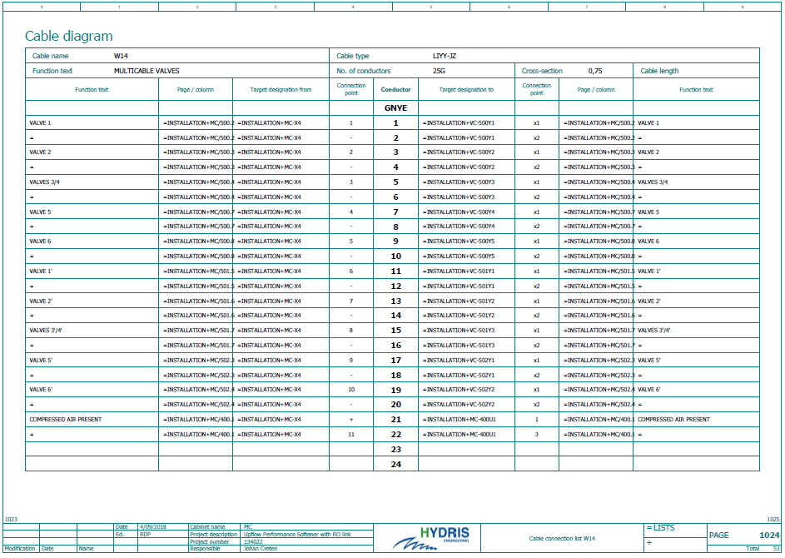

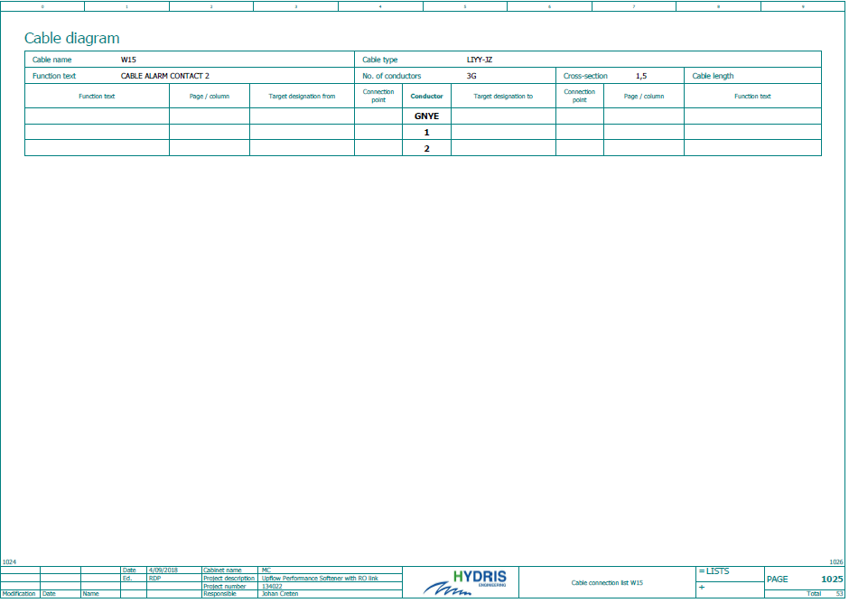

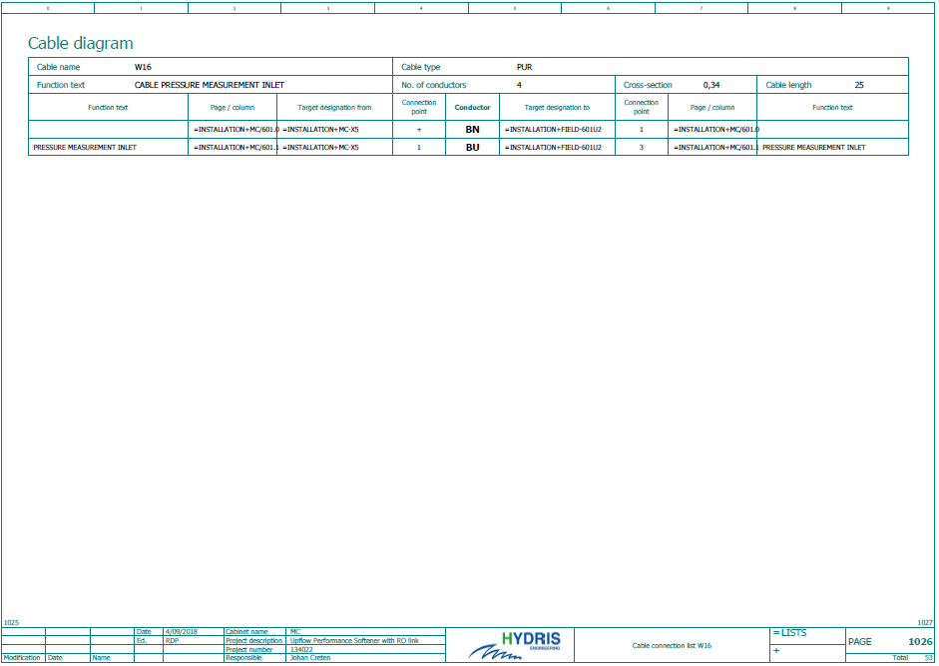

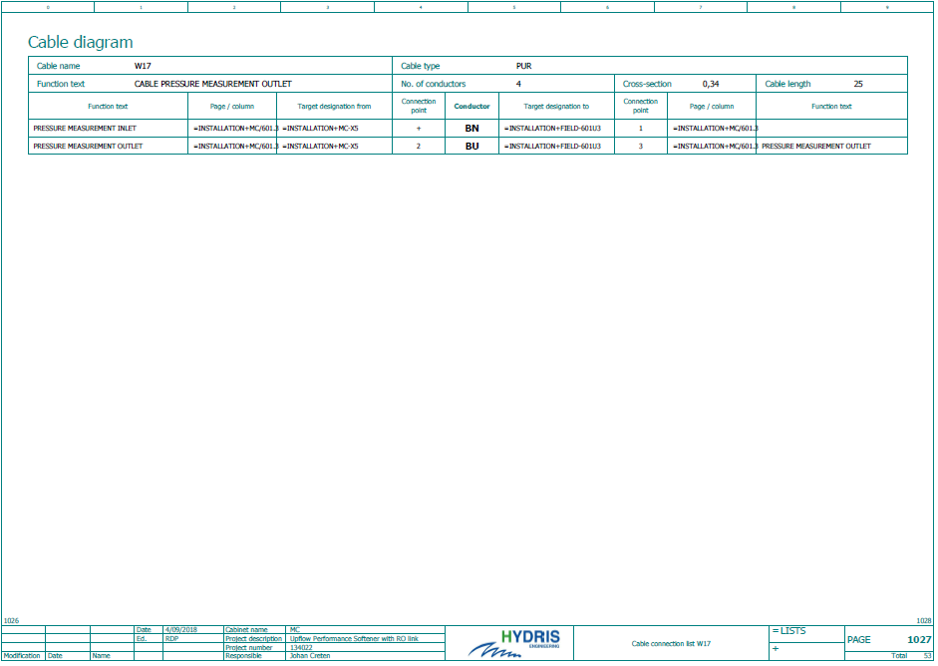

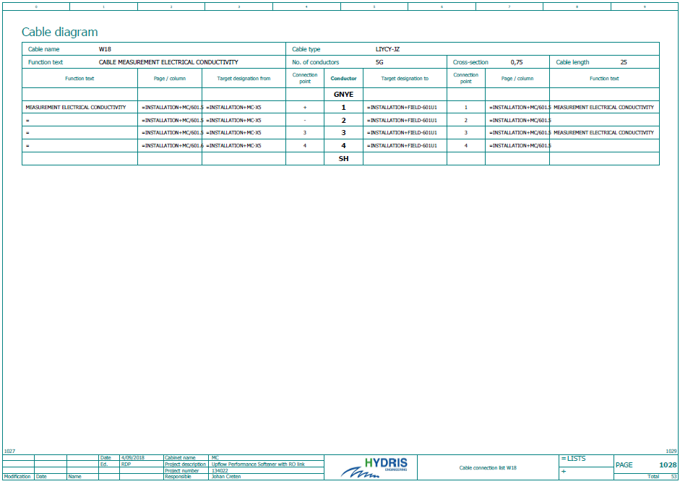

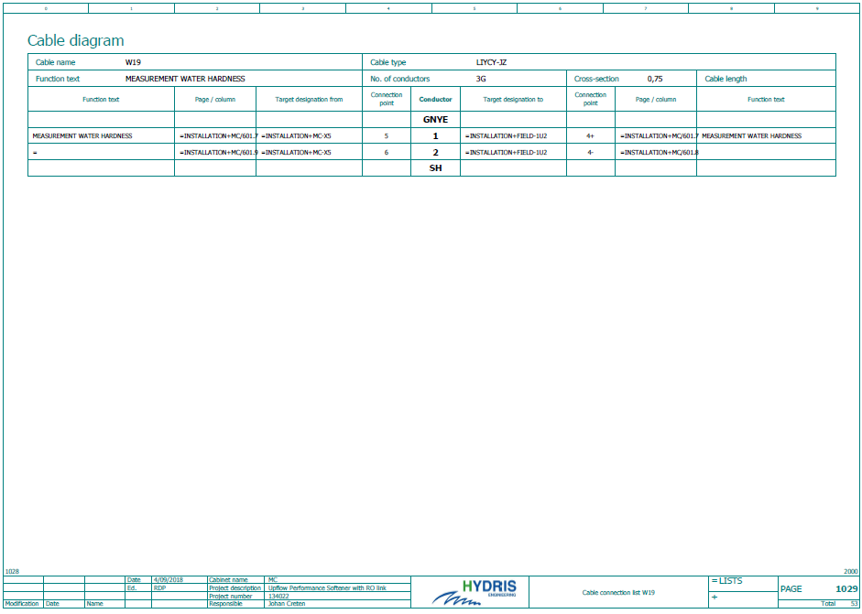

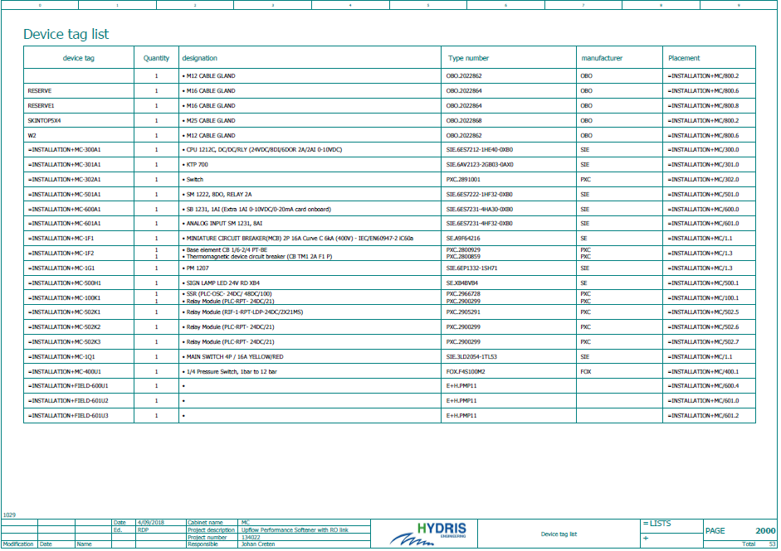

Parts list
 |  | CSoft MV UFS D18 | CSoft MV UFS D21 | CSoft MV UFS D24 | CSoft MV UFS D30
Vessel & Distribution system
Vessel |  | 0101023391 | 0101023393 | 0101023394 | 0101023395
Top distributor |  | 0201023740 | 0201023740 | 0201023740 | 0201023740
Bottom distributor |  | 0201023750 | 0201023752 | 0201023752 | 0201023754
Filter media
Inert resins |  | 0801010005
Bags of 25L
Monodisperse resins |  | 0801010001
Bags of 25L
Support layer (1,7-2,5 mm) |  | 0901016151
Bags of 25kg
Pneumatic valves
IN |  | 1909010064 |  |  | 1909010065
OUT |  | 1909010064 |  |  | 1909010065
DRAIN |  | 1909010060 | 1909010061 |  | 1909010062
BRINE |  |  | 1909010060 |  | 1909010061
Instrumentation
Pressure transmitter |  | On request
Flow pulsmeter - water |  |  | 2803010005 |  | 2803010006
Flow pulsmeter - brine |  |  | 2803010013 |  | 2803010014
Conductivity meter |  | 4810030001
Hardness monitor |  | 4802020003
Hardness indicator |  | 4802030022
Solenoid valve |  | 1908025125
PLC Controller |  | 4709010001
Brine tank & accessories
Brine tank |  | 0602078339 |  | 0602011187 | 0602011255
injector |  |  | 1902018128 |  | 1902011575
Flow meter |  |  | 4807010009 |  | 4807010011

 |  | CSoft MV UFS D36 | CSoft MV UFS D42 | CSoft MV UFS D48 | CSoft MV UFS D55 | CSoft MV UFS D63
Vessel & Distribution system
Vessel |  | 0101033428 | 0101033429 | 0101033430 | 0101033431 | 0101033435
Top distributor |  | 0201043804 | 0201043814 | 0201043832 | 0201043834 | 0201043836
Bottom distributor |  | 0201043812 | 0201043822 | 0201043832 | 0201043834 | 0201043836
Filter media
Inert resins  Bags of 25L |  |  |  | 0801010005
Resins  Bags of 25L |  |  |  | 0801010001
Support layer (1,7-2,5 mm)  Bags of 25kg |  |  |  | 0901016151
Pneumatic valves
IN |  | 1906012055 | 1906012056 |  | 1906012057
OUT |  | 1906012061 | 1906012062 |  | 1906012063
DRAIN |  | 1909010063 |  | 1909010063 | 1909010064
BRINE |  | 1909010061 |  | 1909010062 |  | 1909010063
Instrumentation
Pressure transmitter |  |  |  | On request
Flow pulsmeter - water |  | 2803000007 | 2803000008 |  | 2803000009
Flow pulsmeter - brine |  | 2803010014 |  | 2803010015 |  | 2803010016
Conductivity meter |  |  |  | 4810030001
Hardness monitor |  |  |  | 4802020003
Hardness indicator |  |  |  | 4802030022
Solenoid valve |  |  |  | 1908025125
PLC Controller |  |  |  | 4709010001
Brine tank & accessories
Brine tank |  | 0602011259 |  | 0602011261 | 0602011263 | On request
injector |  | 1902011575 | 1902011576 | 1902010045 |  | 1902010046
Flow meter |  | 4807010011 | 4807010013 | 4807010014 | 4807010016

EC declaration

EC DECLARATION OF CONFORMITY FOR MACHINERY
(Directive 89/392/EEC)

Manufacturer: Hydris bvba
Address : Textielstraat 13, 8790 Waregem, Belgium

Hereby declares that:

the water treatment system with our reference ‘Pallas Duplex Upflow Softener’, consisting of:
- Composite tank Pentair (97/23/EC)
- Pneumatic controlled valves Gemü (2014/68/EU)
- Lewatit resins (EU 1935/2004 – RESAP(2004)3)
- Siemens S7 control panel (2014/35/EU)
- Digital pressure sensors IFM (2011/65/EU & 2014/30/EU)
- Conductivity meter E+H (2014/30/EU)
- Residue hardness meter Sycon (2014/35/EU)

complies with the provisions of the Machinery directive (Directive 89/392/EEC, as amended), and with the national legislation for the implementation of this directive and its additions.

Drawn up in Waregem (Belgium), on 3 October 2017

Johan Creten
General Manager

Brine tank excluded
Brine tank excluded

